

(CSEN604) Data Bases II

*Supervised by: Dr. Wael Abouelsaadat*

Schema 1

Query 1:

Planning time and execution time with no index:

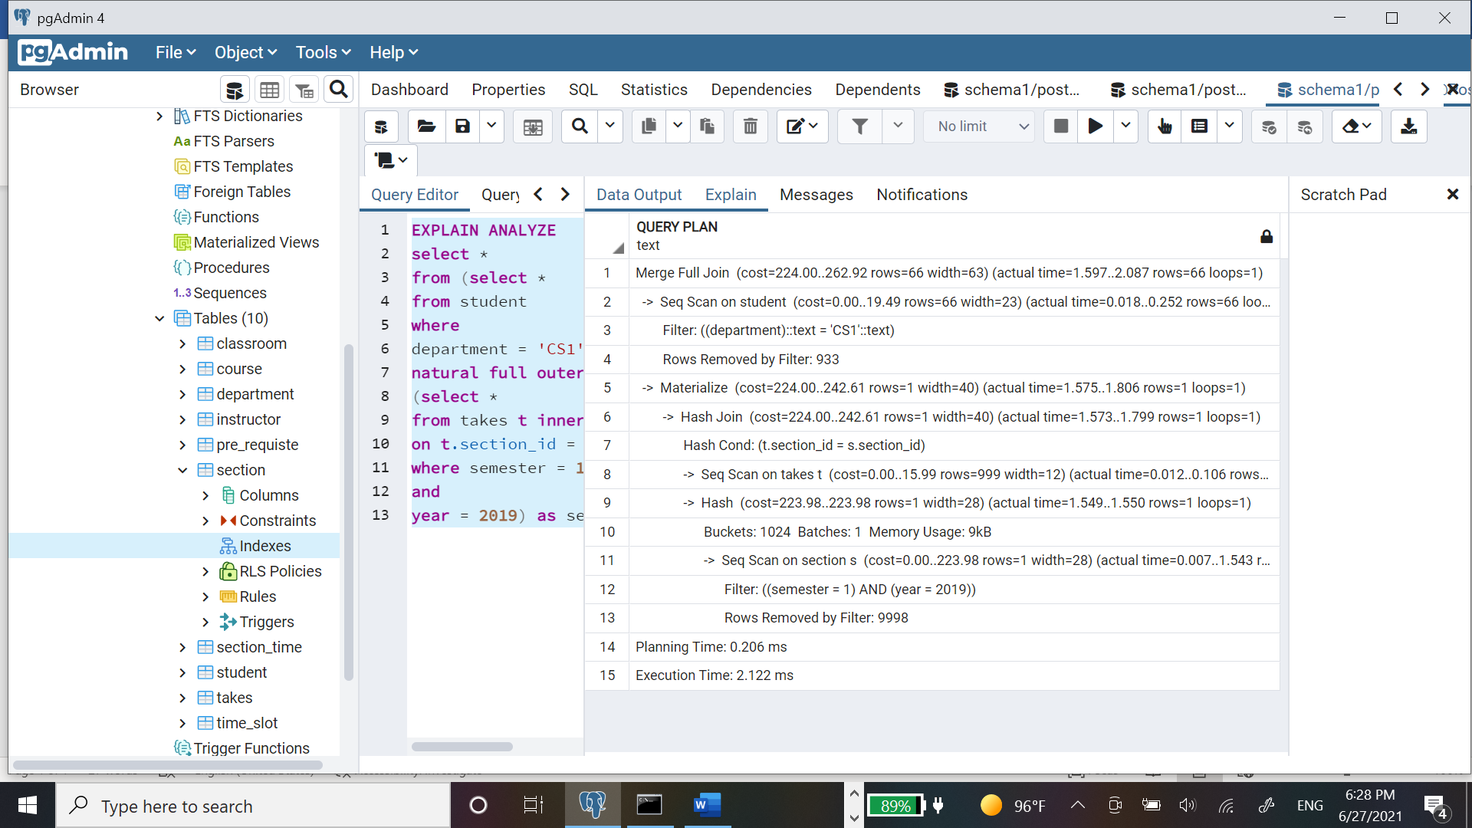

Planning and execution time using B+Trees on department:

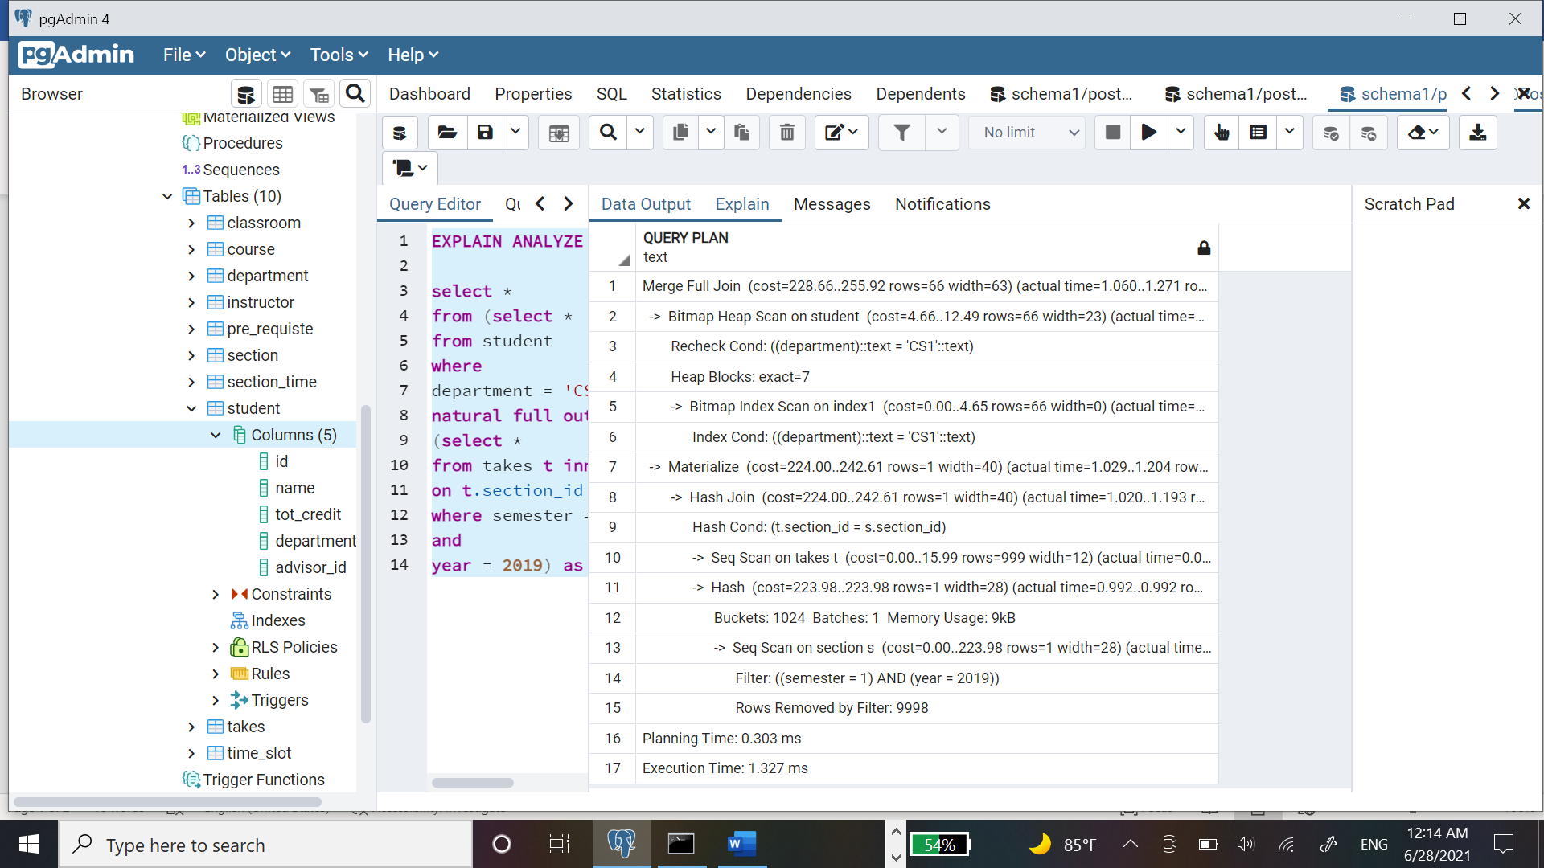

Planning and execution time using B+Trees on year and semester:

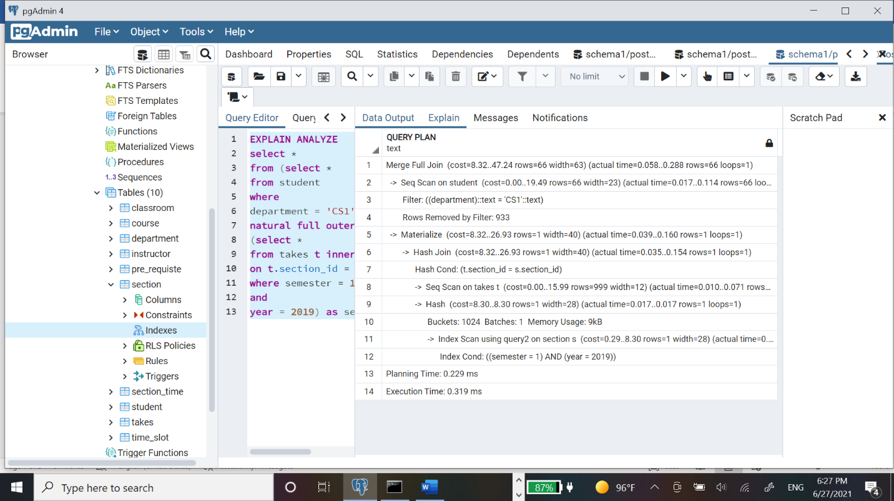

Planning and execution time using hash on semester:

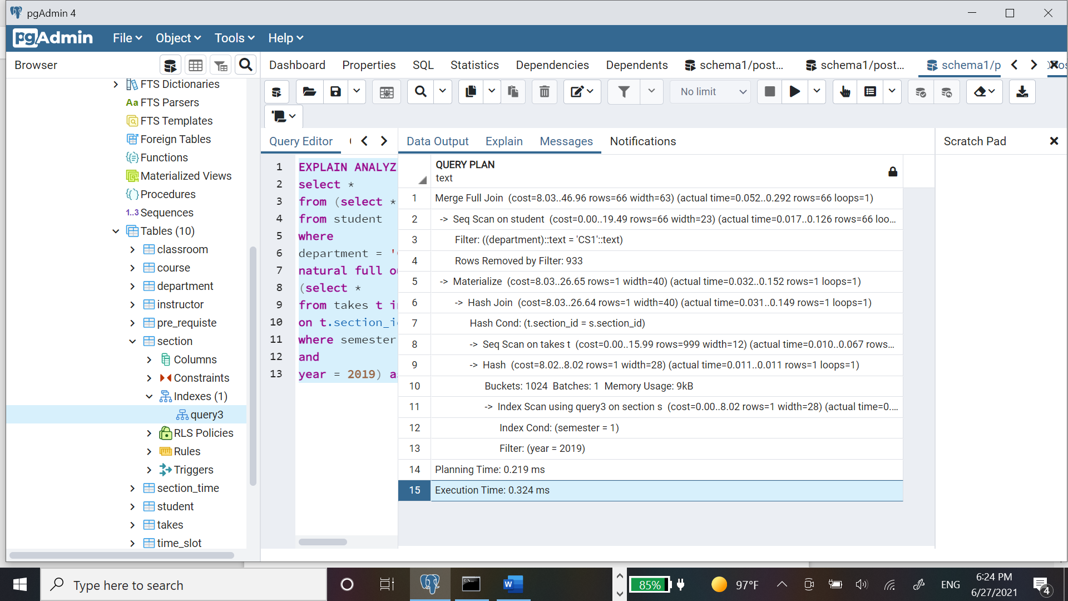

Using hash on department:

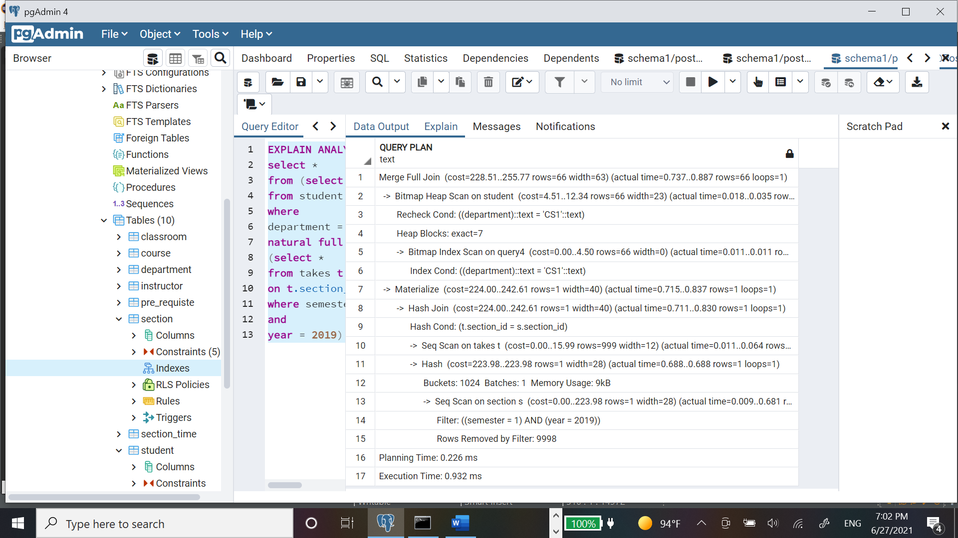

Using hash on year:

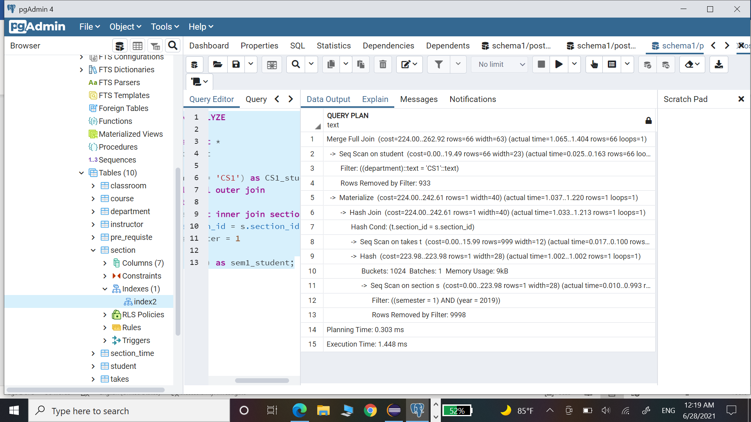

Planning and execution time using mixed indices B+tree on year and semester and hash on department:

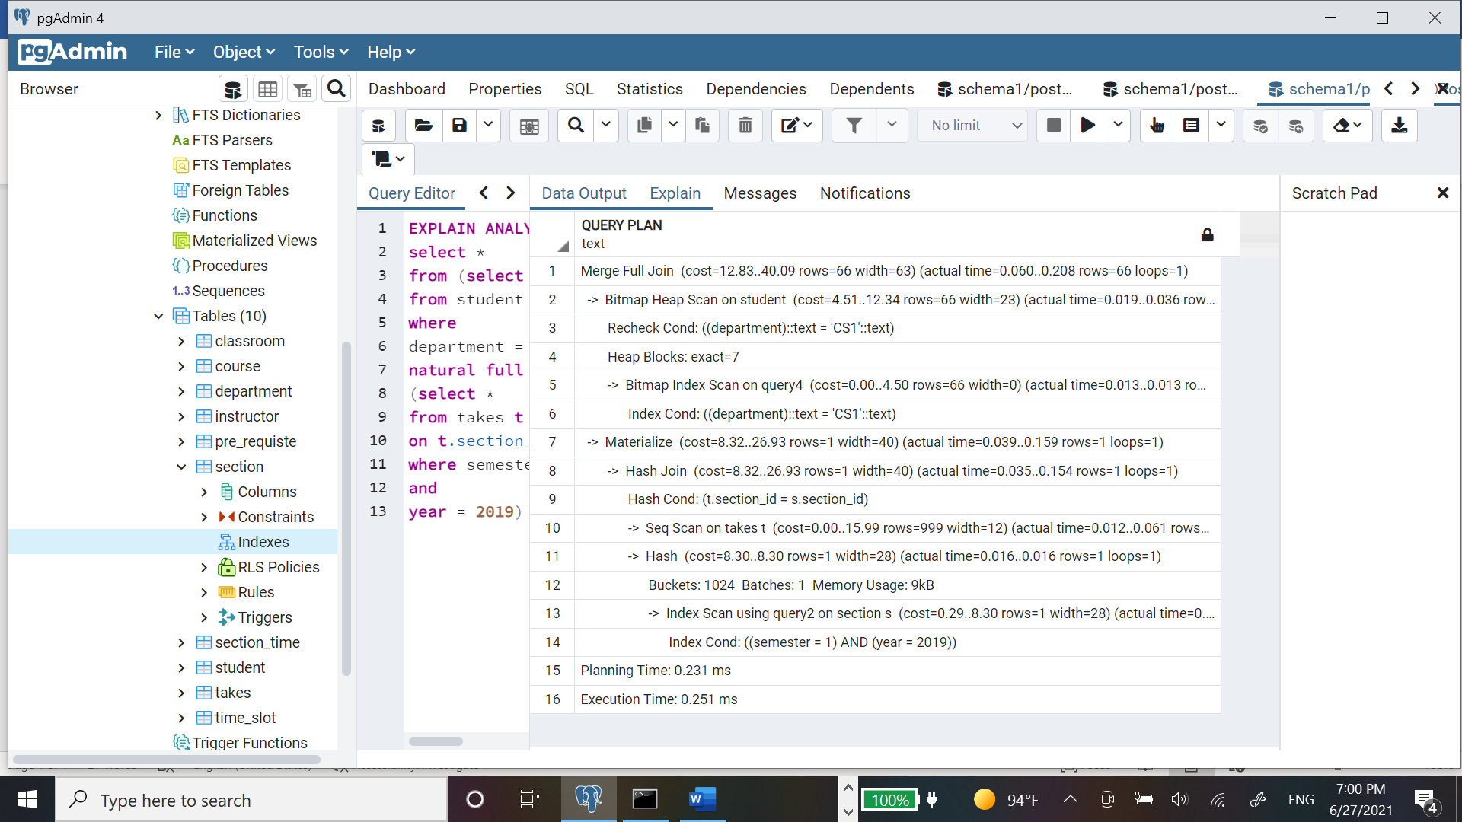

Report Summary:

By checking the results shown above we can deduce that the execution time significantly improved when using indices. Best option would be mix between B+tree on year and semester and hash on department so that all columns we are performing a query on are indexed. B+ tree runs faster when on year and semester or even on of them only as B+tree is better used on numerical data. Hash is insignificantly slower than B+tree.

Without index: 2.122 ms

With B+tree on department: 1.327 ms

With B+tree on year and semester: 0.319 ms

With hash on semester: 0.324ms

With hash on department: 0.932ms

With hash on year: 1.448ms

With mixed indices B+tree on year and semester and hash on department:0.251ms

Schema 2

Query 2

*Scenario 1(No index)*

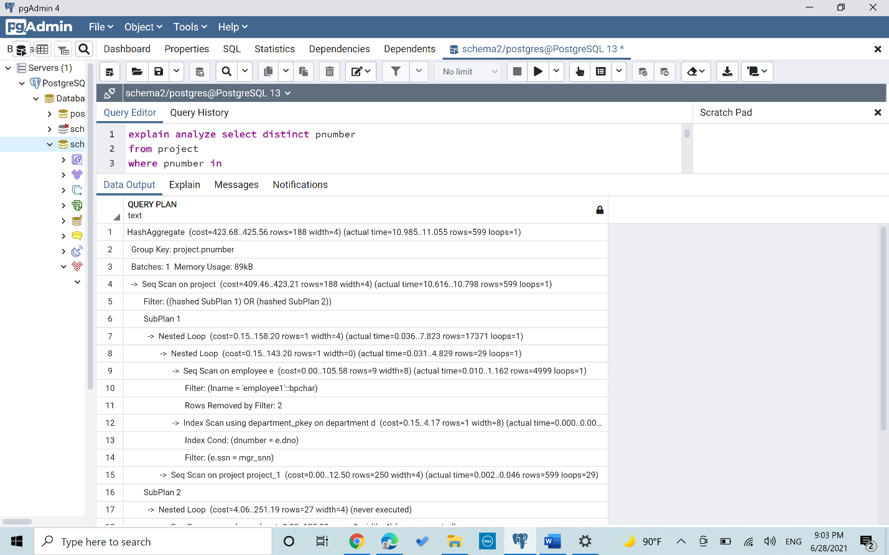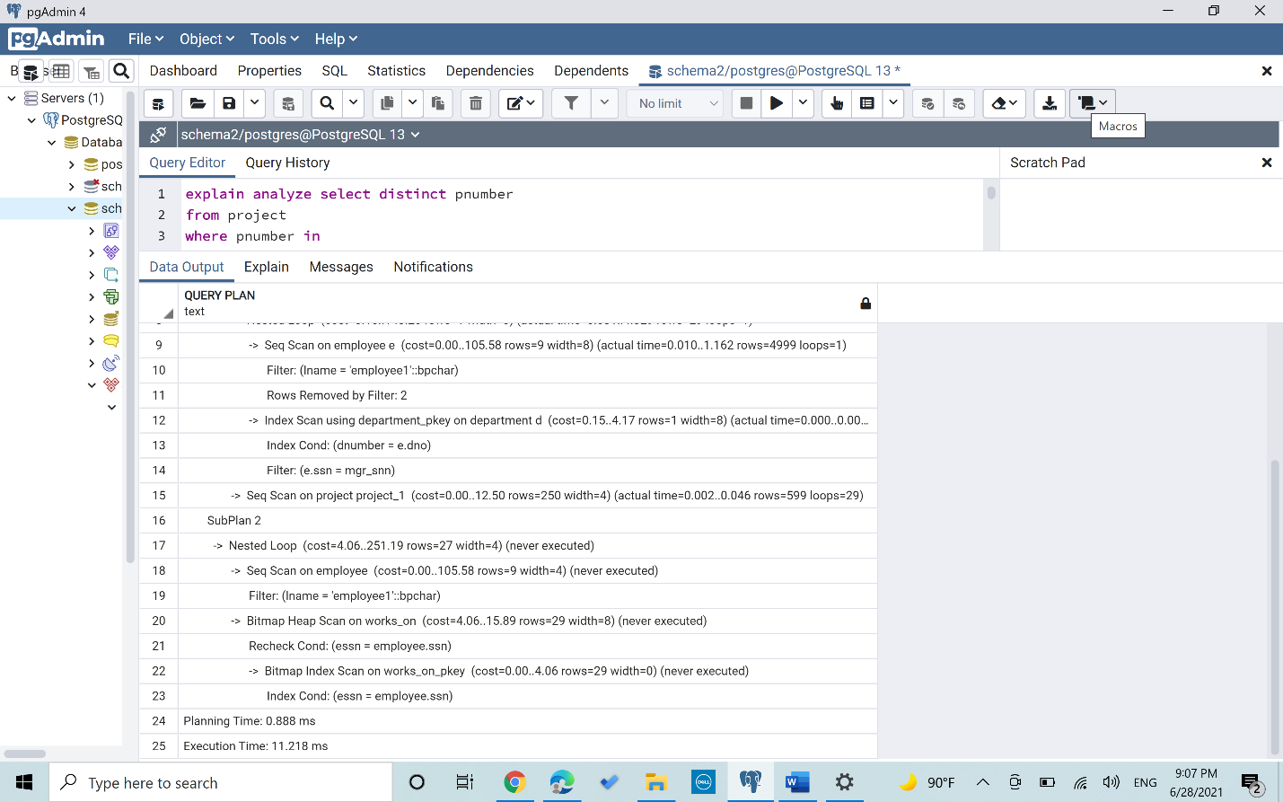

*Scenario 2(B+ Tree index on Ssn in Employee)*

*“Used B+ index on ssn because it is accessed in every loop that happens in the query, thus shortening the time”*

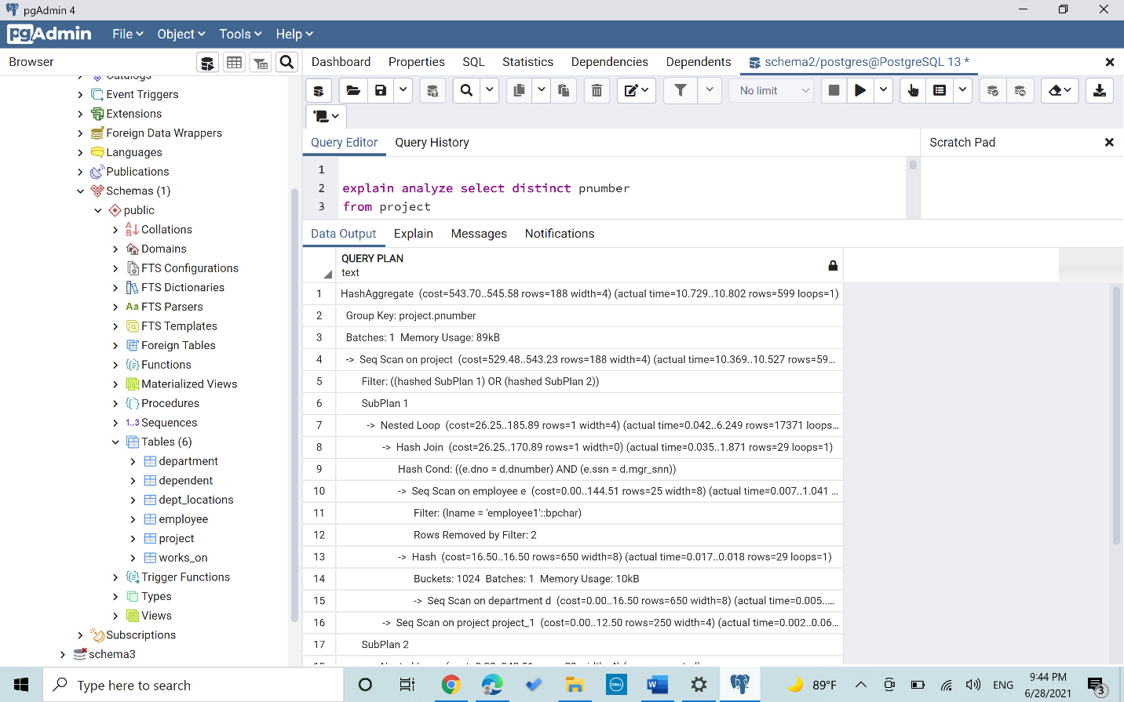

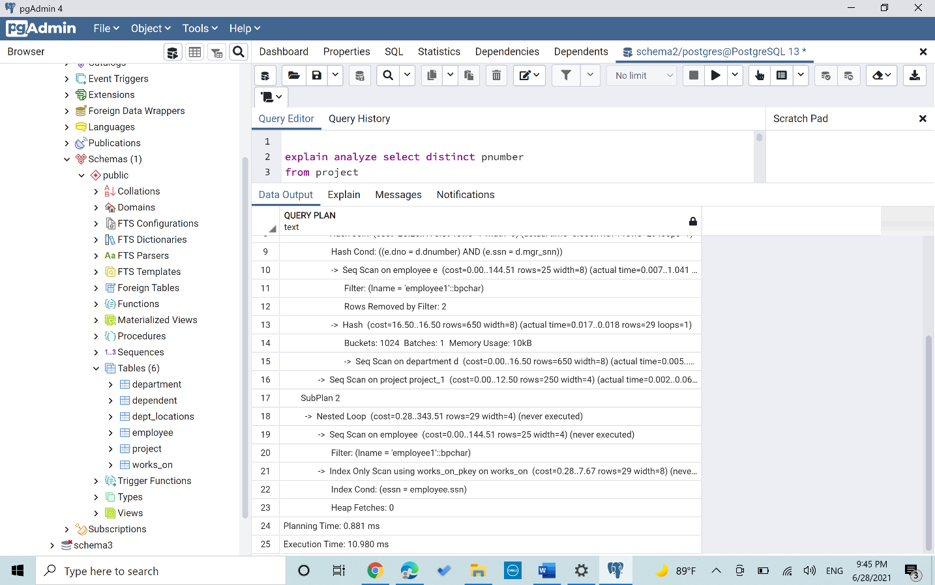

*Scenario 3(Hash index on Ssn in Employee)*

*“Used Hash index on ssn because it is accessed in every loop that happens in the query, thus shortening the time”*

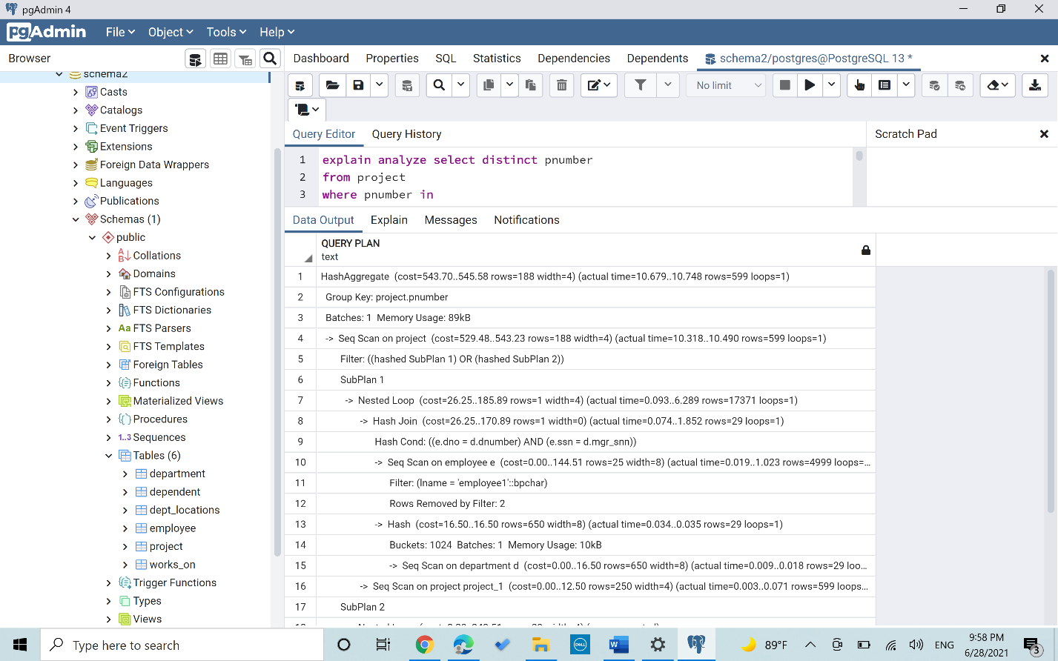

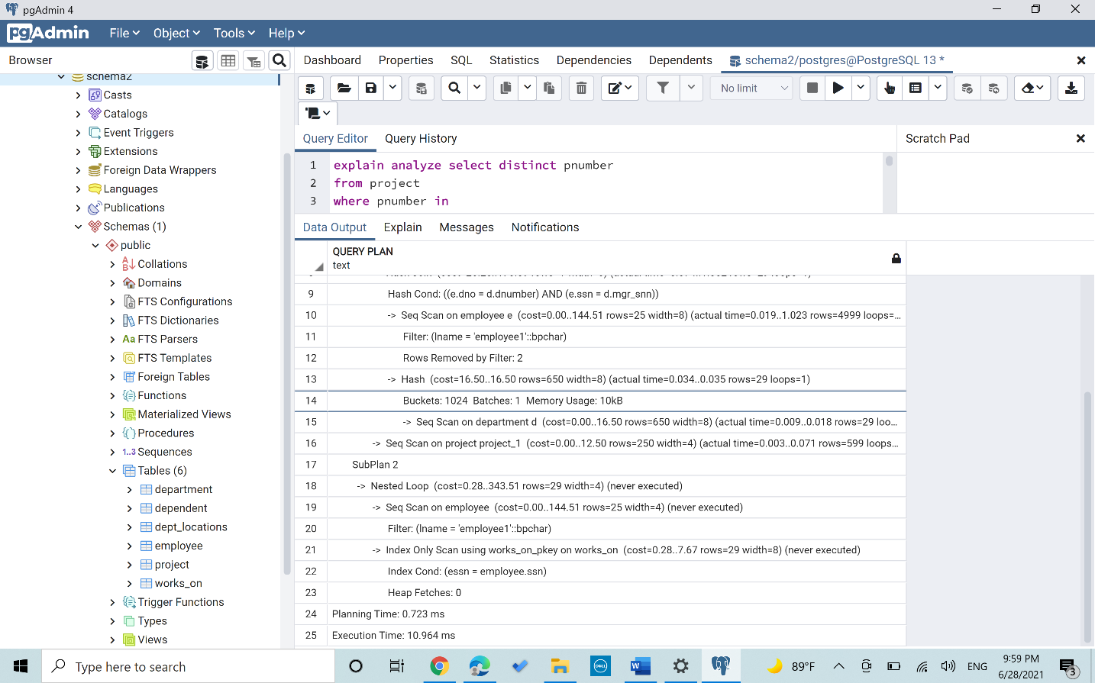

*Scenario 4(Mixed index [Hash on Ssn, B+ on Dnumber on Department])*

*“I used here the a hash index on ssn because it is accessed at everyloop and also the dnumber is accessed many times so I used B+ index with it thus the time decreased drastically compared to the 3 previous runs”*

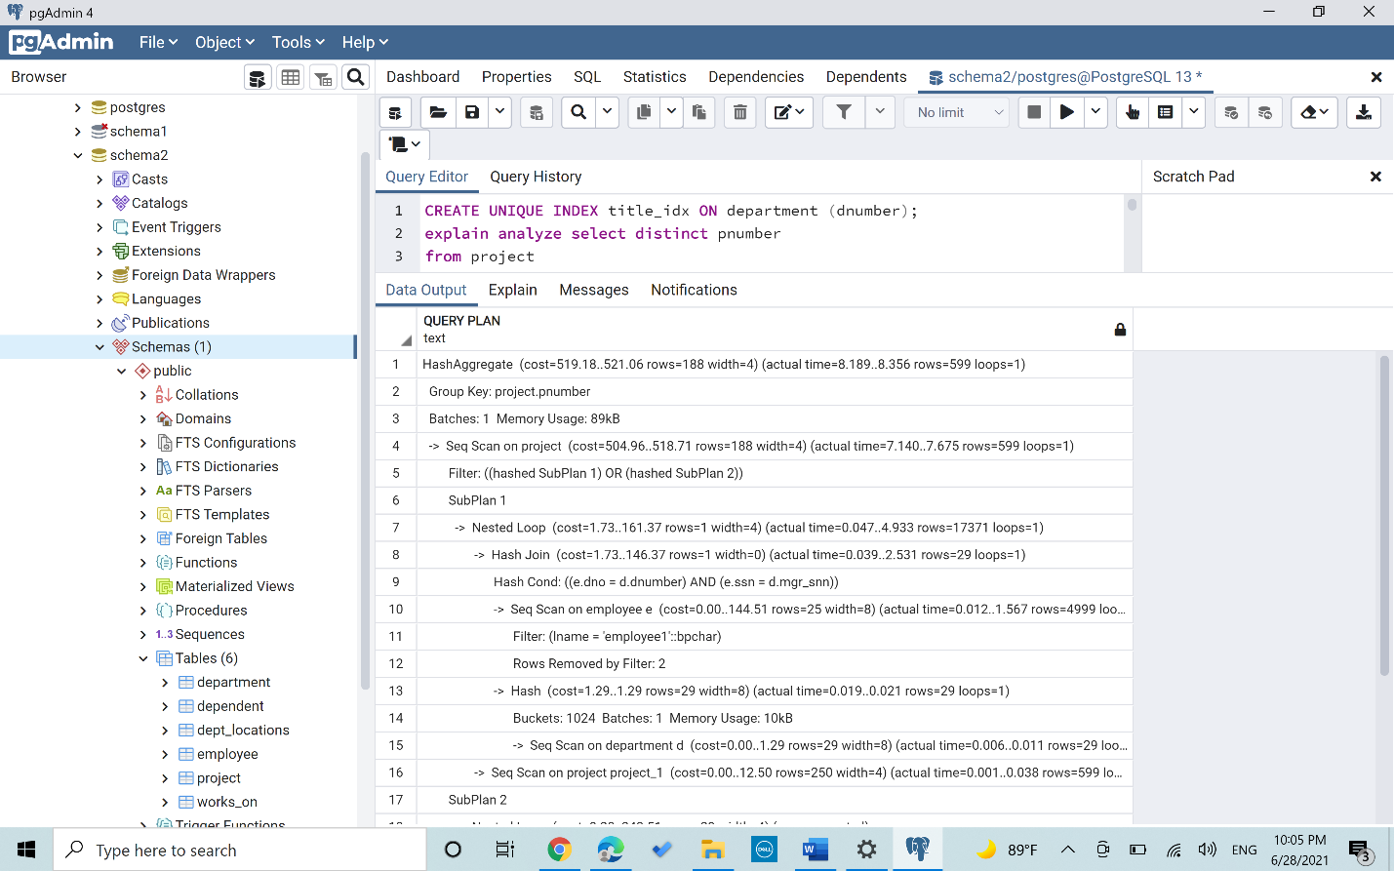

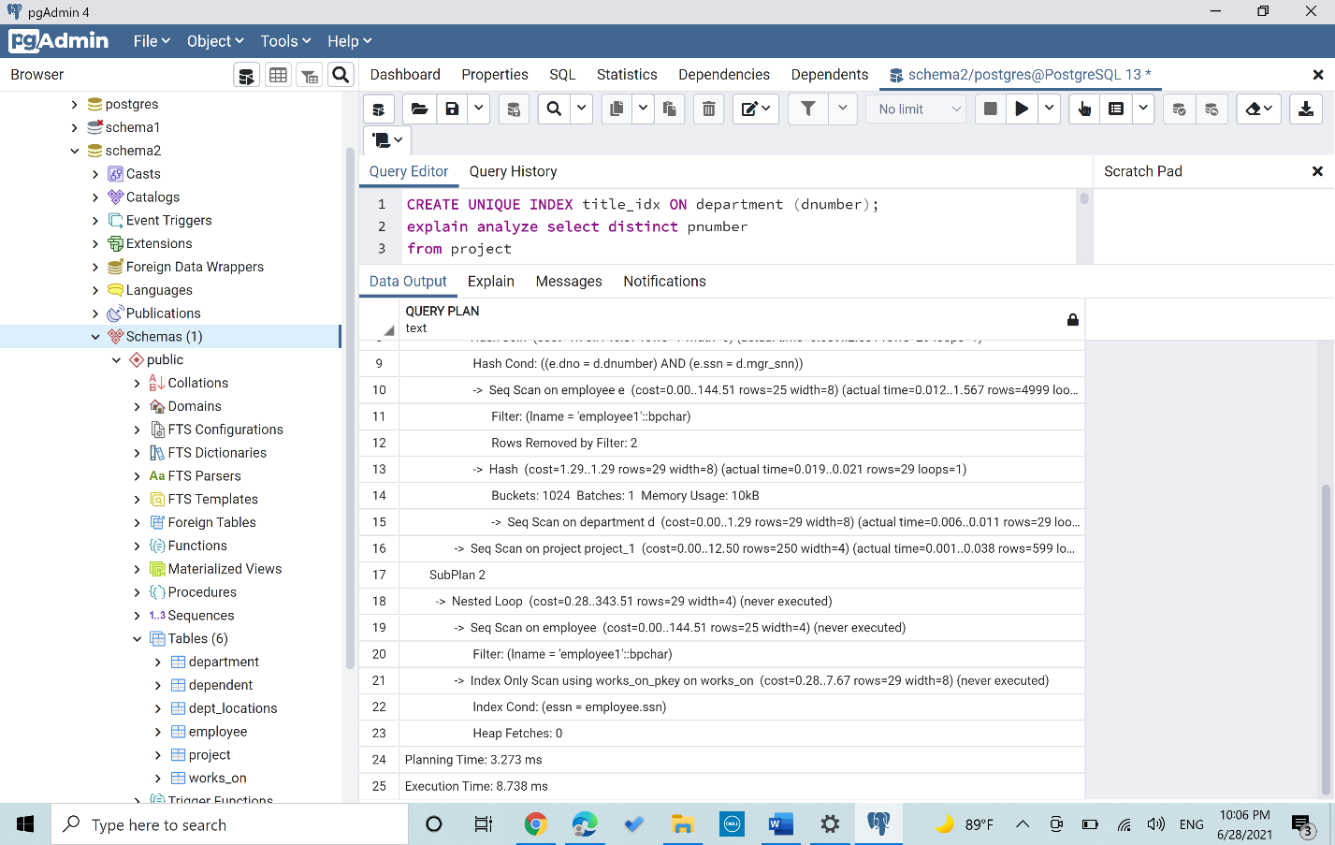

Query 3

*Scenario 1(No index)*

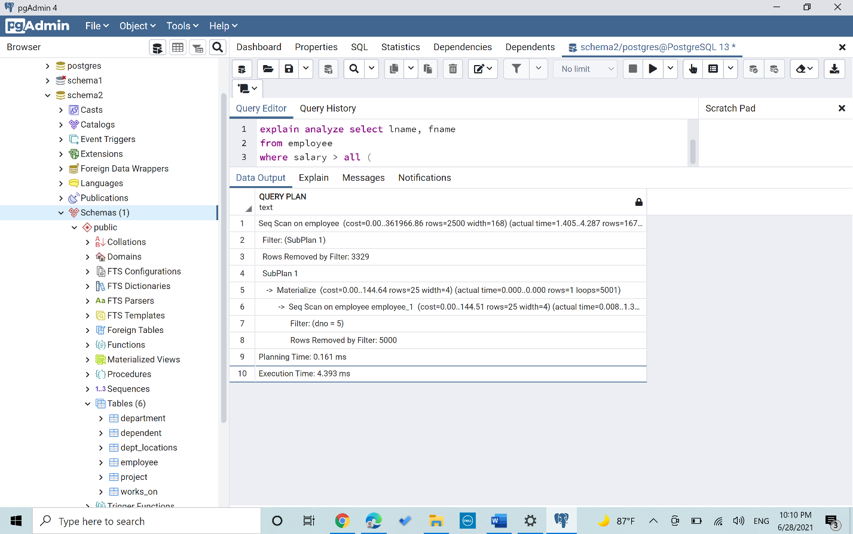

*Scenario 2(B+ Tree index on Dnumber in Department)*

*“All the retrieved events should have a salary of those who have the dnumber=5, thus ordering by using the B+ index, the dnumber will surely make the execution faster”*

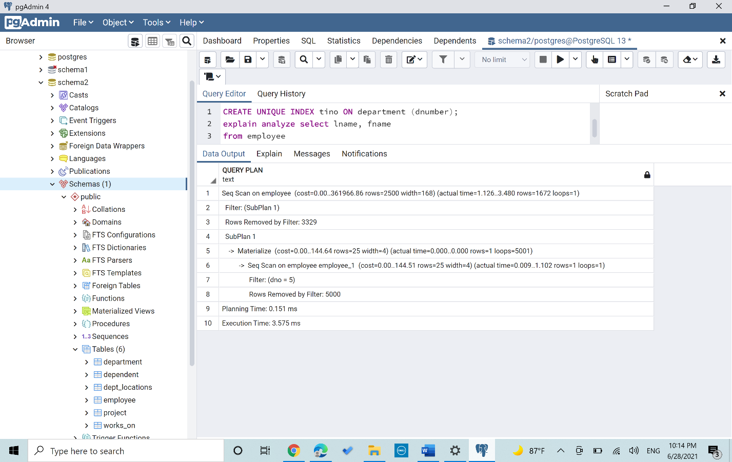

*Scenario 3(Hash index on Salary in Employee )*

*“All the retrieved employees should have salary>than all the salaries of those who have d=no5, thus ordering by using the Hash index, the salary will surely make the execution faster”*

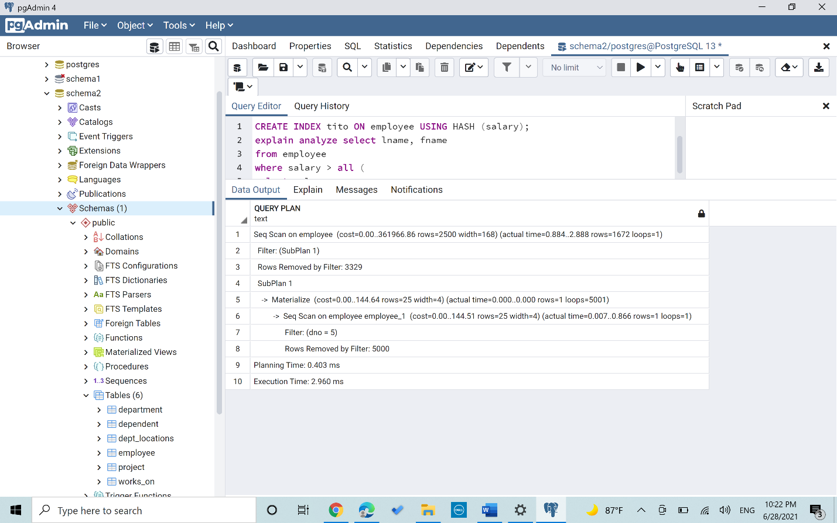

*Scenario 4(Mixed index[B+ on dnumber,Hash on salary])*

*“Using both indexes on dnumber the B+ and on the salary using the Hash resulted in a shorter execution time than the original query”*

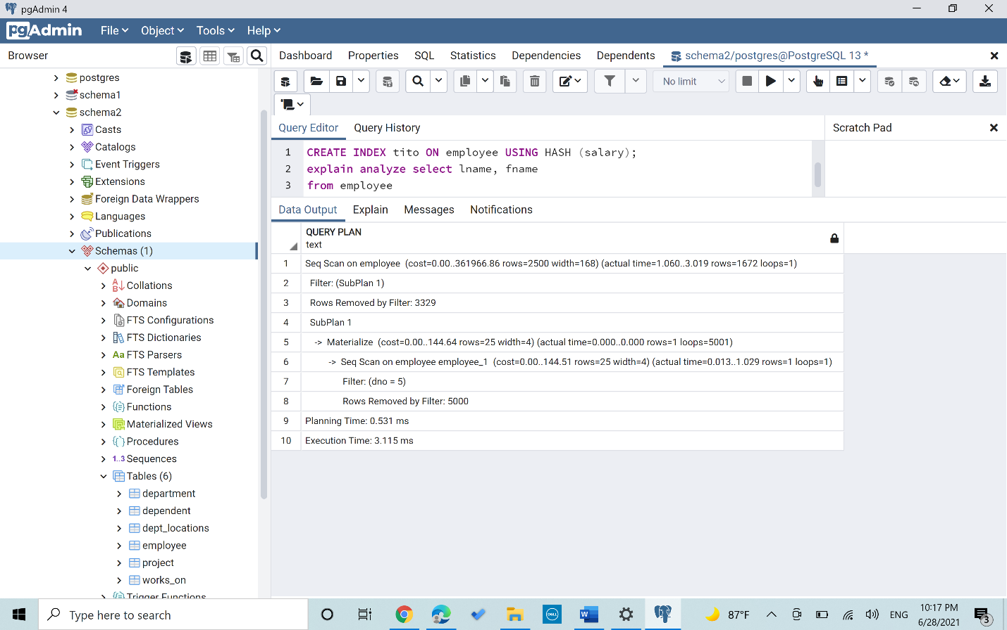

Query 4

*Scenario 1(No index)*

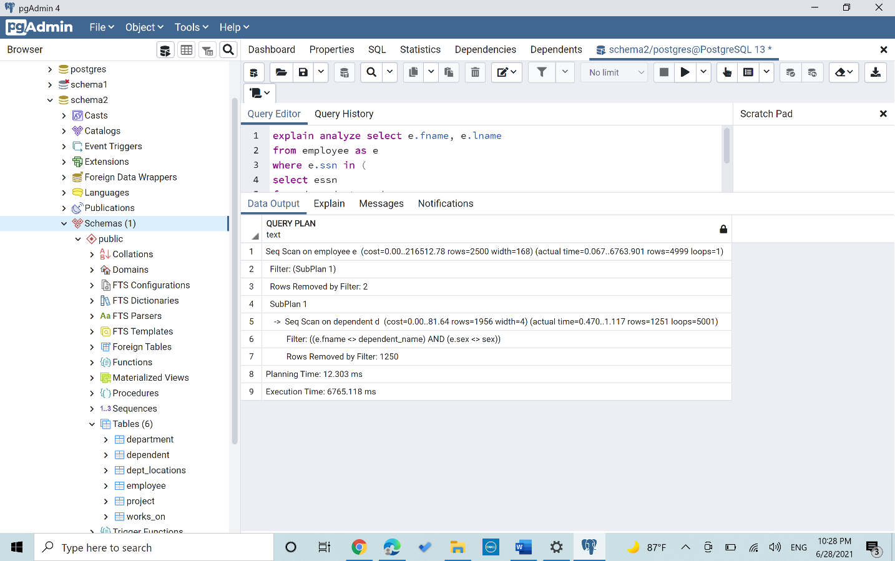

*Scenario 2(B+ Tree index on fname in Employee)*

*“fname is always compared with the dependent name so using the B+ index on the fname will make the execution time less”*

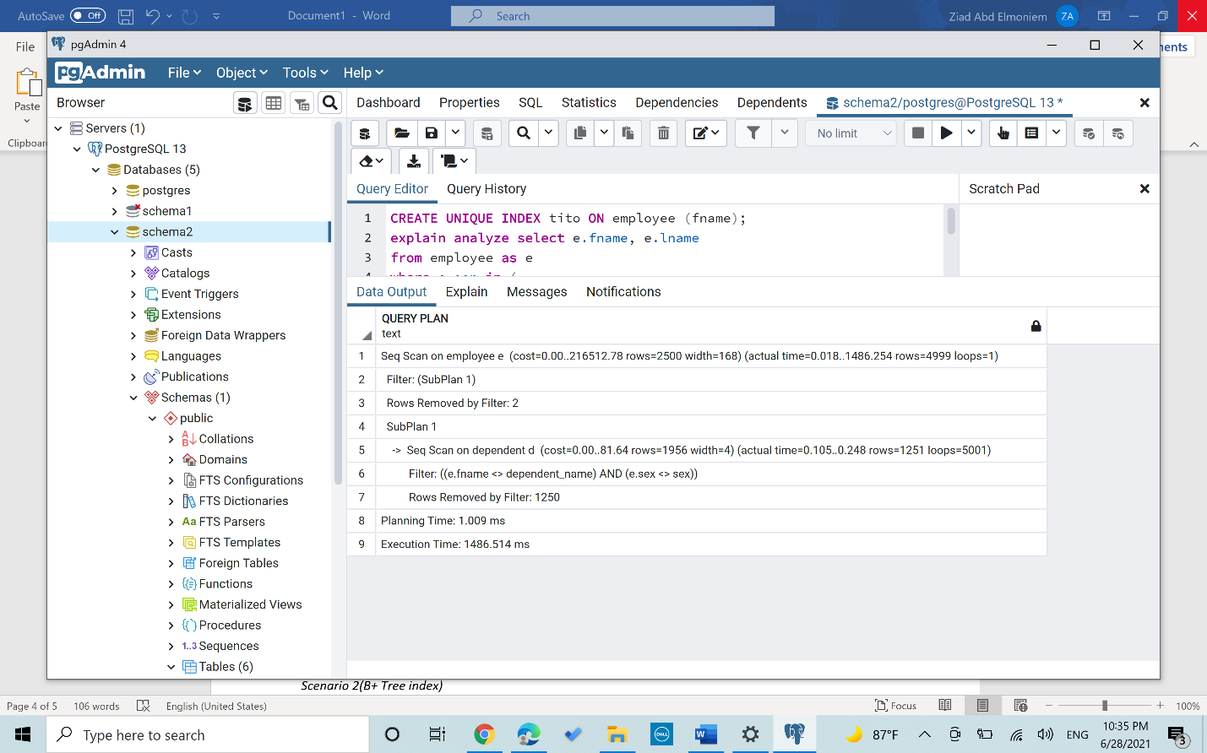

*Scenario 3(Hash index on sex in Employee)*

*“the sex of the employee is always compared so using also a hash index with will make the execution tim less”*

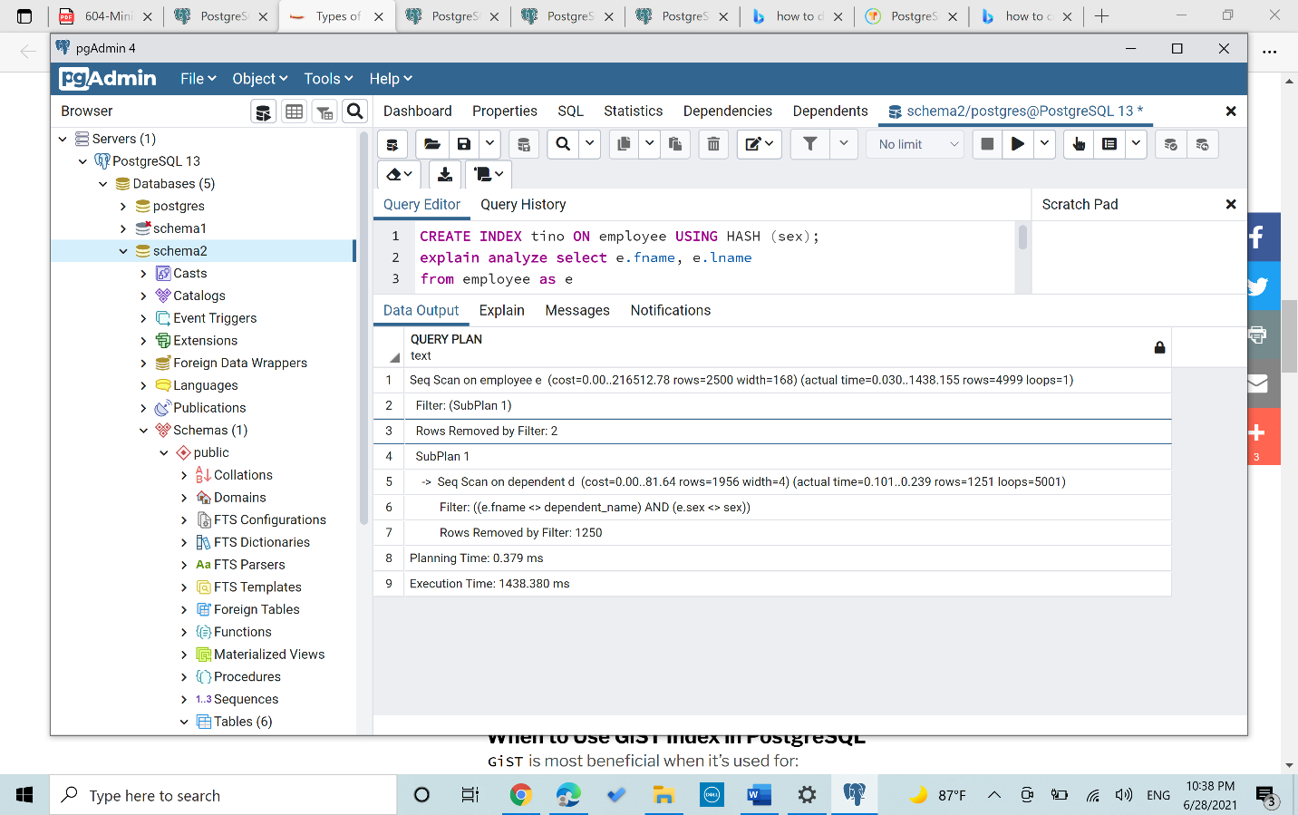

*Scenario 4(Mixed index[B+ on fname, Hash on sex])*

*“Using 2 index increased the planning time but decreased the overall execution time and resulted in the best performance”*

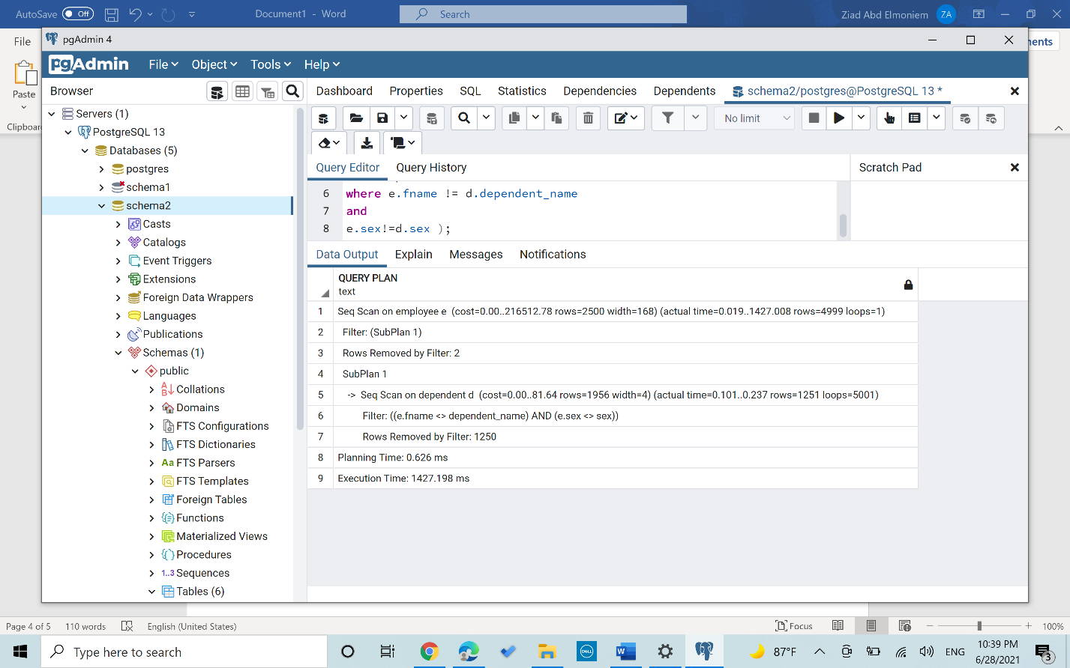

Query 5

*Scenario 1(No index)*

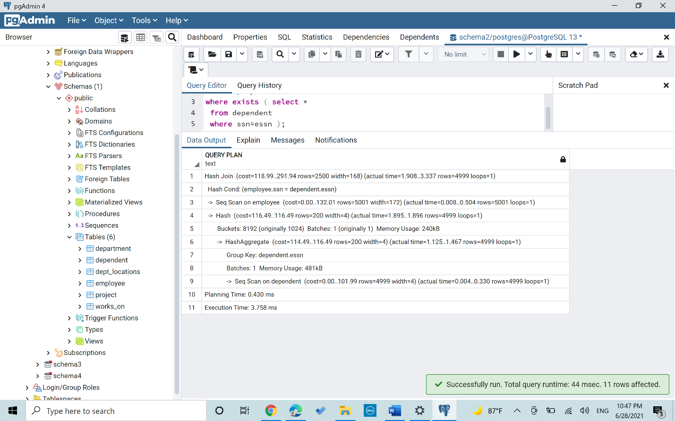

*Scenario 2(B+ Tree index on Ssn in Employee)*

*“The query only check on the ssn in employee and compare it with essn in dependent so creating a B+ index on ssn normally decreased the time”*

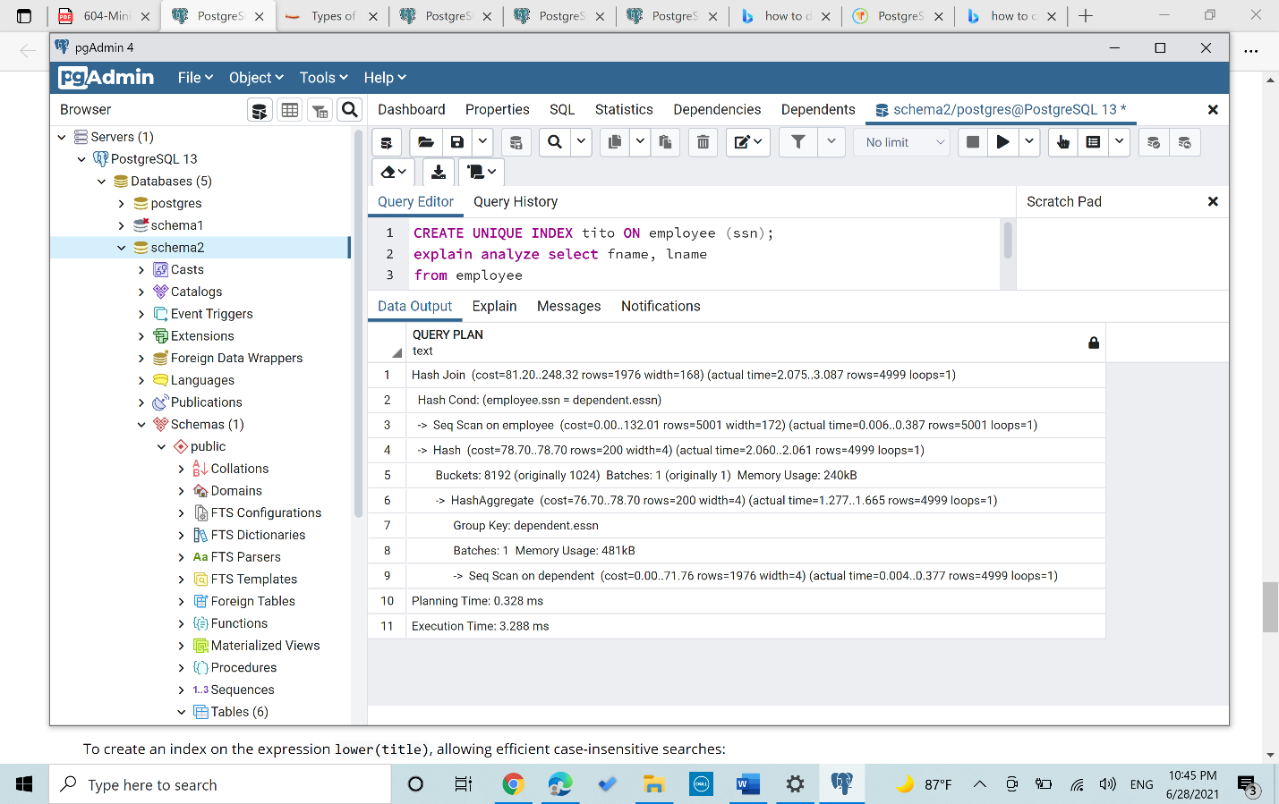

*Scenario 3(Hash index on essn in dependent)*

*“The query only check on the ssn in employee and compare it with essn in dependent so creating a B+ index on essn normally decreased the time”*

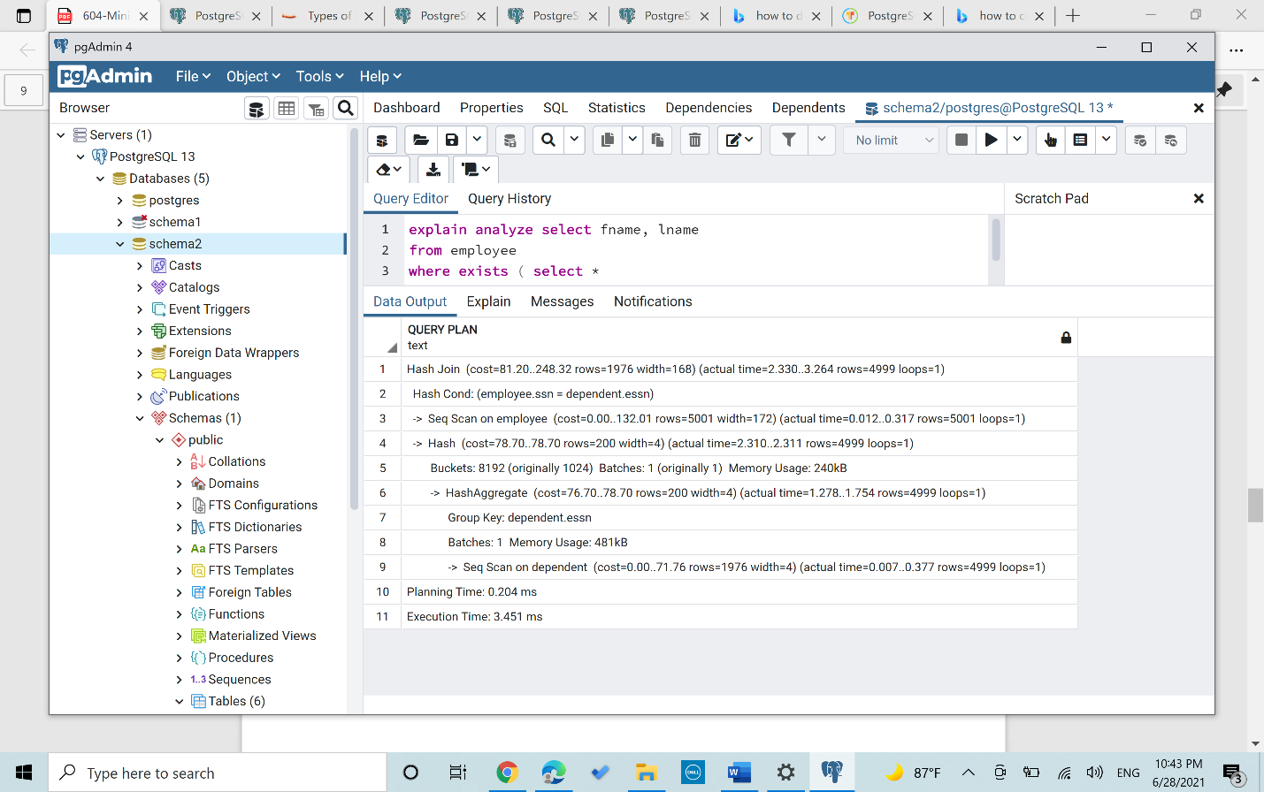

*Scenario 4(Mixed index[B+ on SSn,Hash on essn ])*

*“The query only check on the ssn in employee and compare it with essn in dependent so creating a B+ index on ssn and essn resulted in the least execution time”*

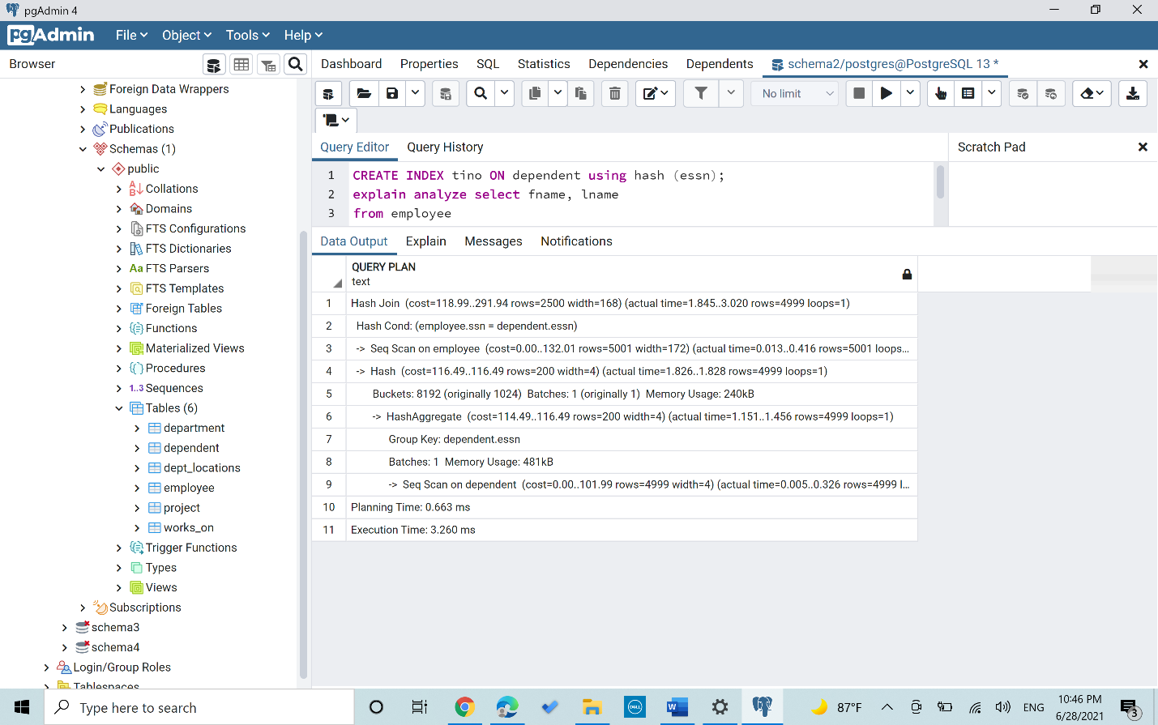

Query 6

*Scenario 1(No index)*

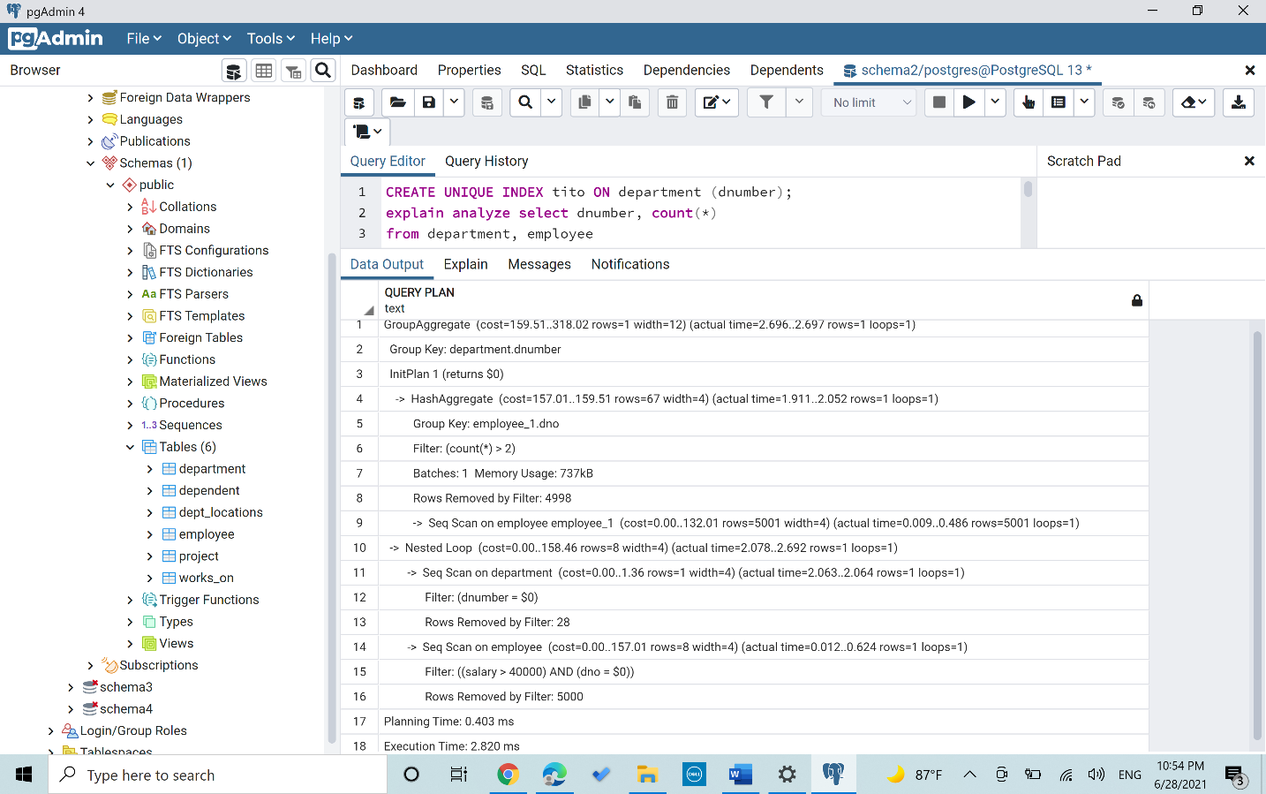

*Scenario 2(B+ Tree index on Dnumber on department)*

*“In the nested query the dno is always compared so having a B+ index on it decreased the time taken to execute it”*

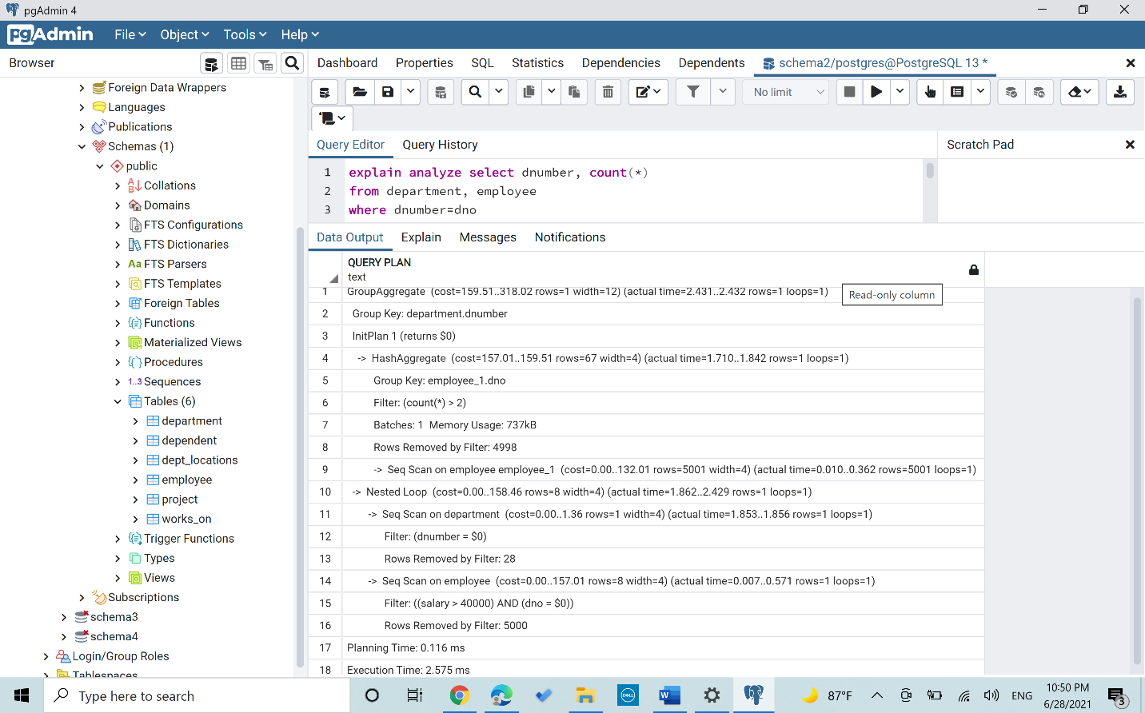

*Scenario 3(Hash index on Salary in Employee)*

*“There is a condition where the salary should always be greater than 40000 thus having a hash index on it will decrease the execution time”*

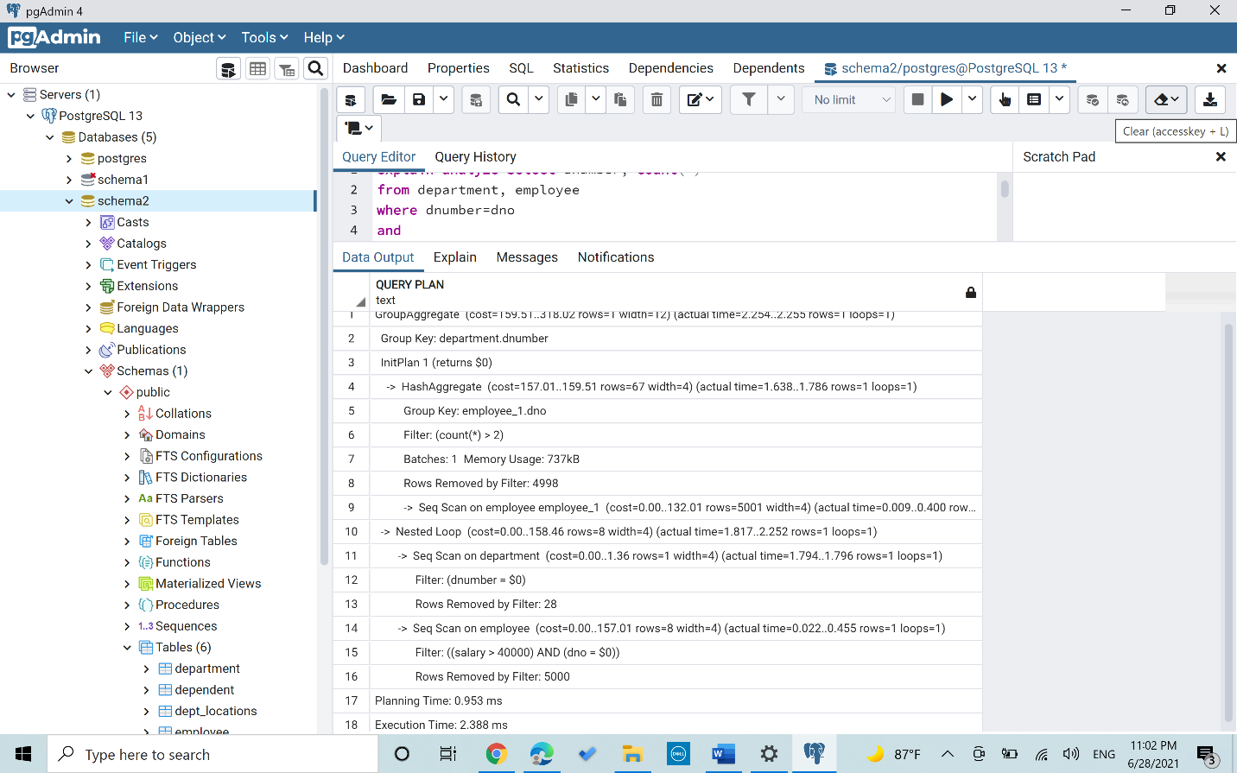

*Scenario 4(Mixed index [Hash on Salary,B+ on dnumber])*

*“Having both indexes resulted in the best performance in the execution time”*

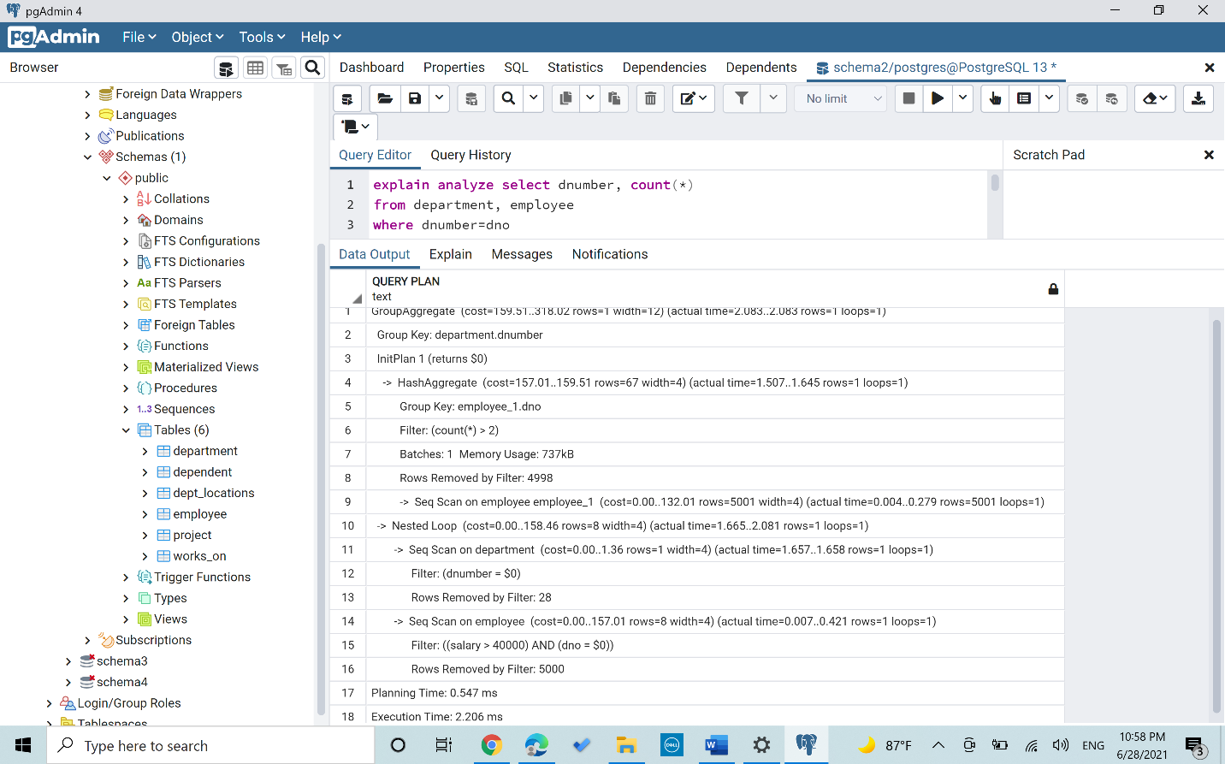

Schema 3

Query 7:

First of all, I analyzed both tables (sailors, reserves) to collect statistics to help us getting accurate estimates building the plan.

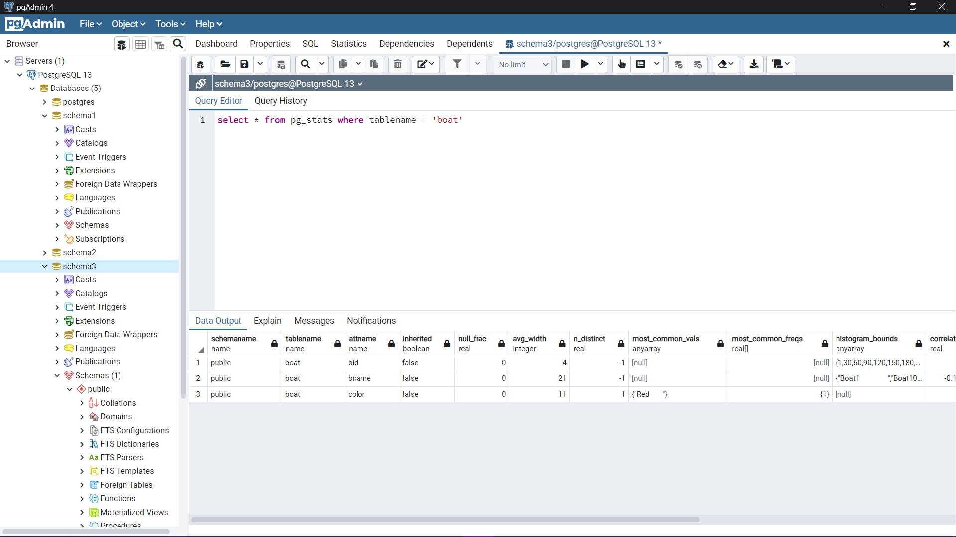

*“select * from pg_stats where tablename = ‘boat’ ”*

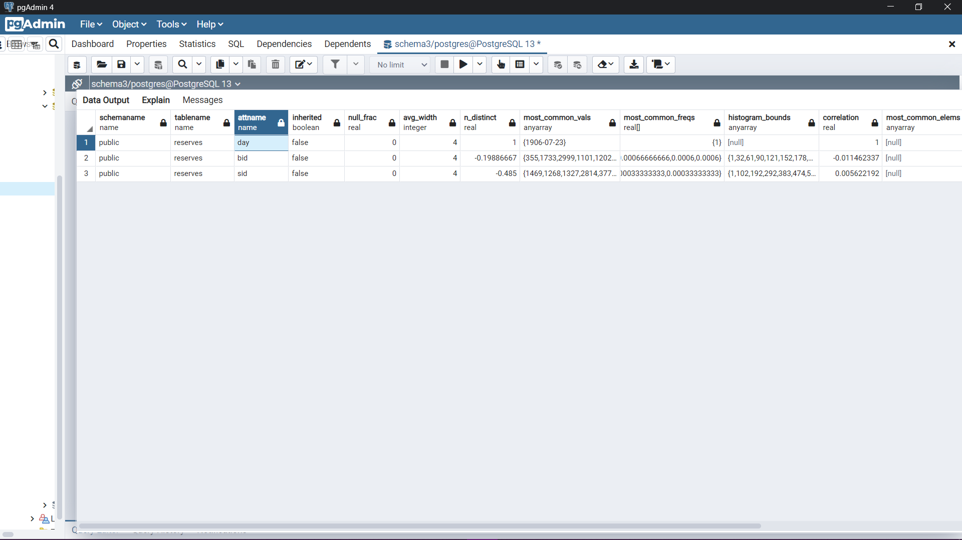

*“select * from pg_stats where tablename = ‘reserves’ ”*

Then I modified how PostgreSQL consider plans by disabling nested loops

*“SET enable_nestloop=false”*

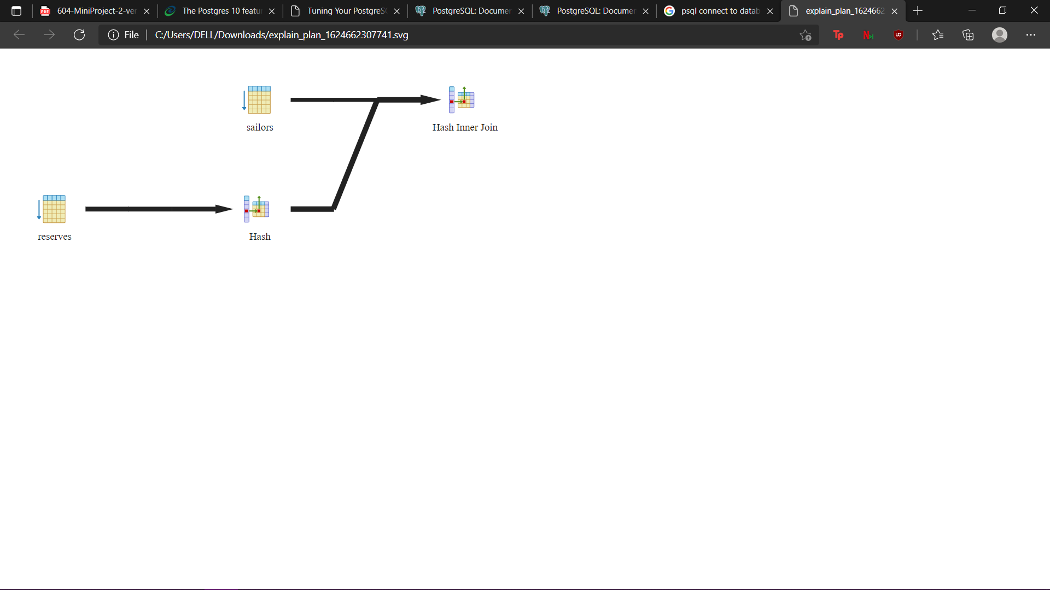

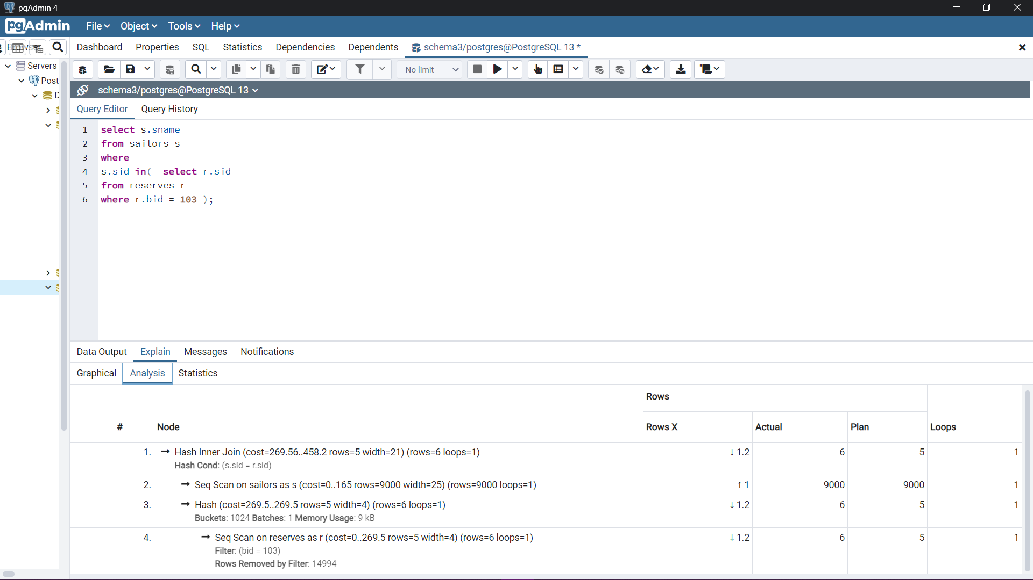

*"Planning Time: 0.352 ms"*

*"Execution Time: 6.027 ms"*

Scenario 1 (No index):

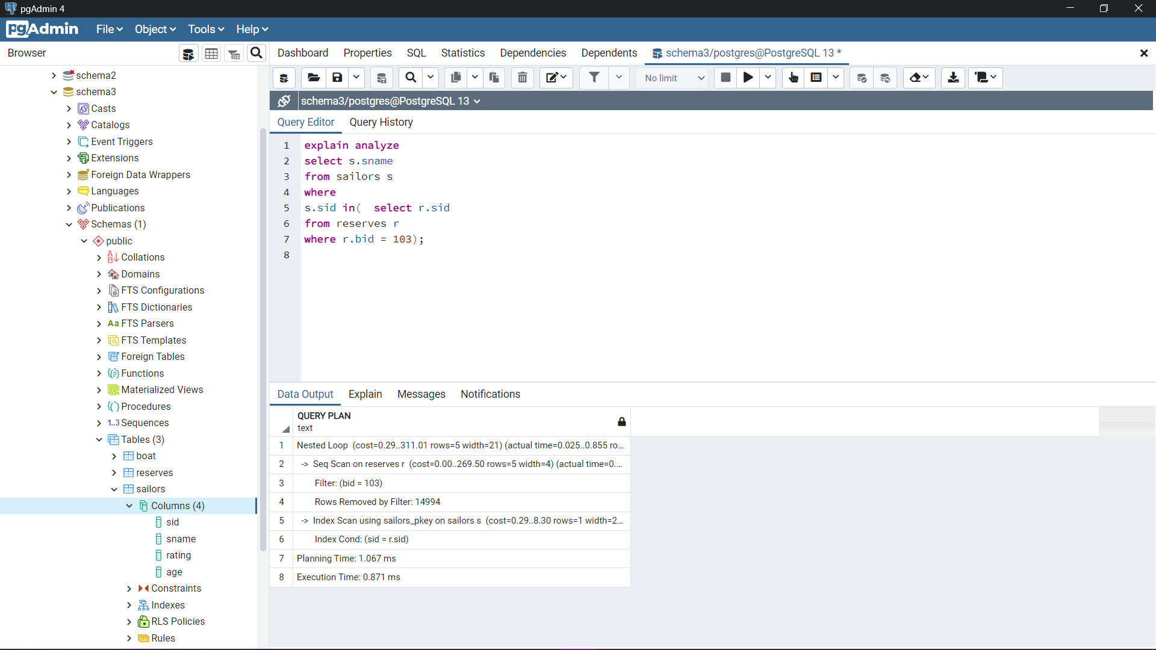

Scenario 2 (B+ tree index):

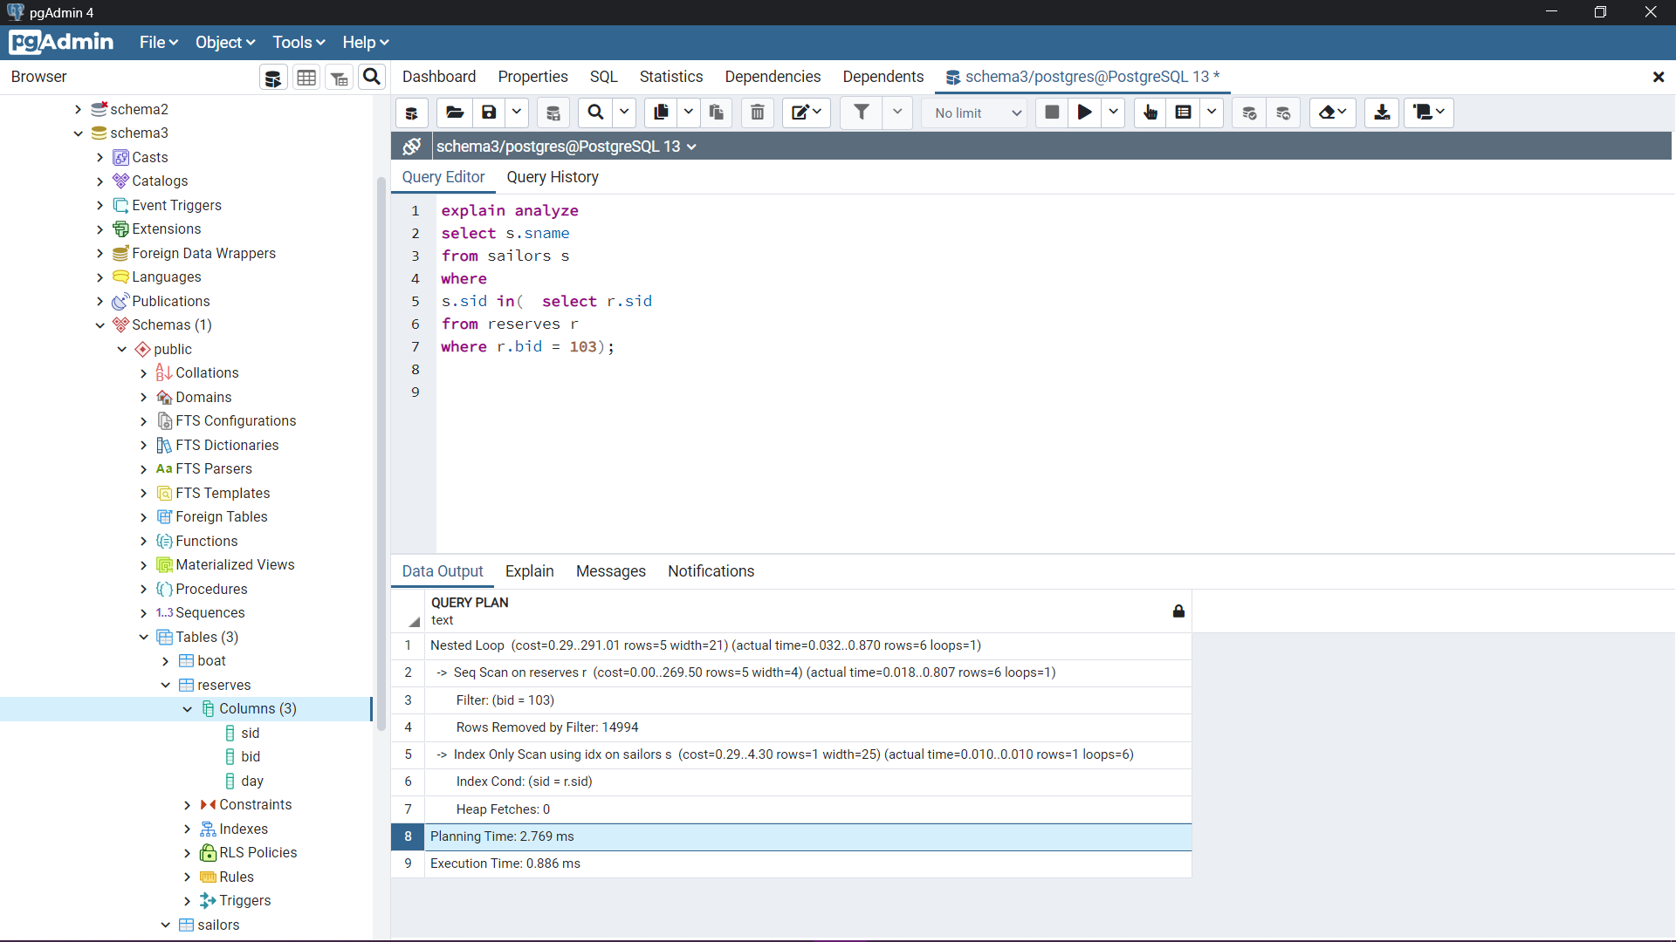

Scenario 3 (Hash index):

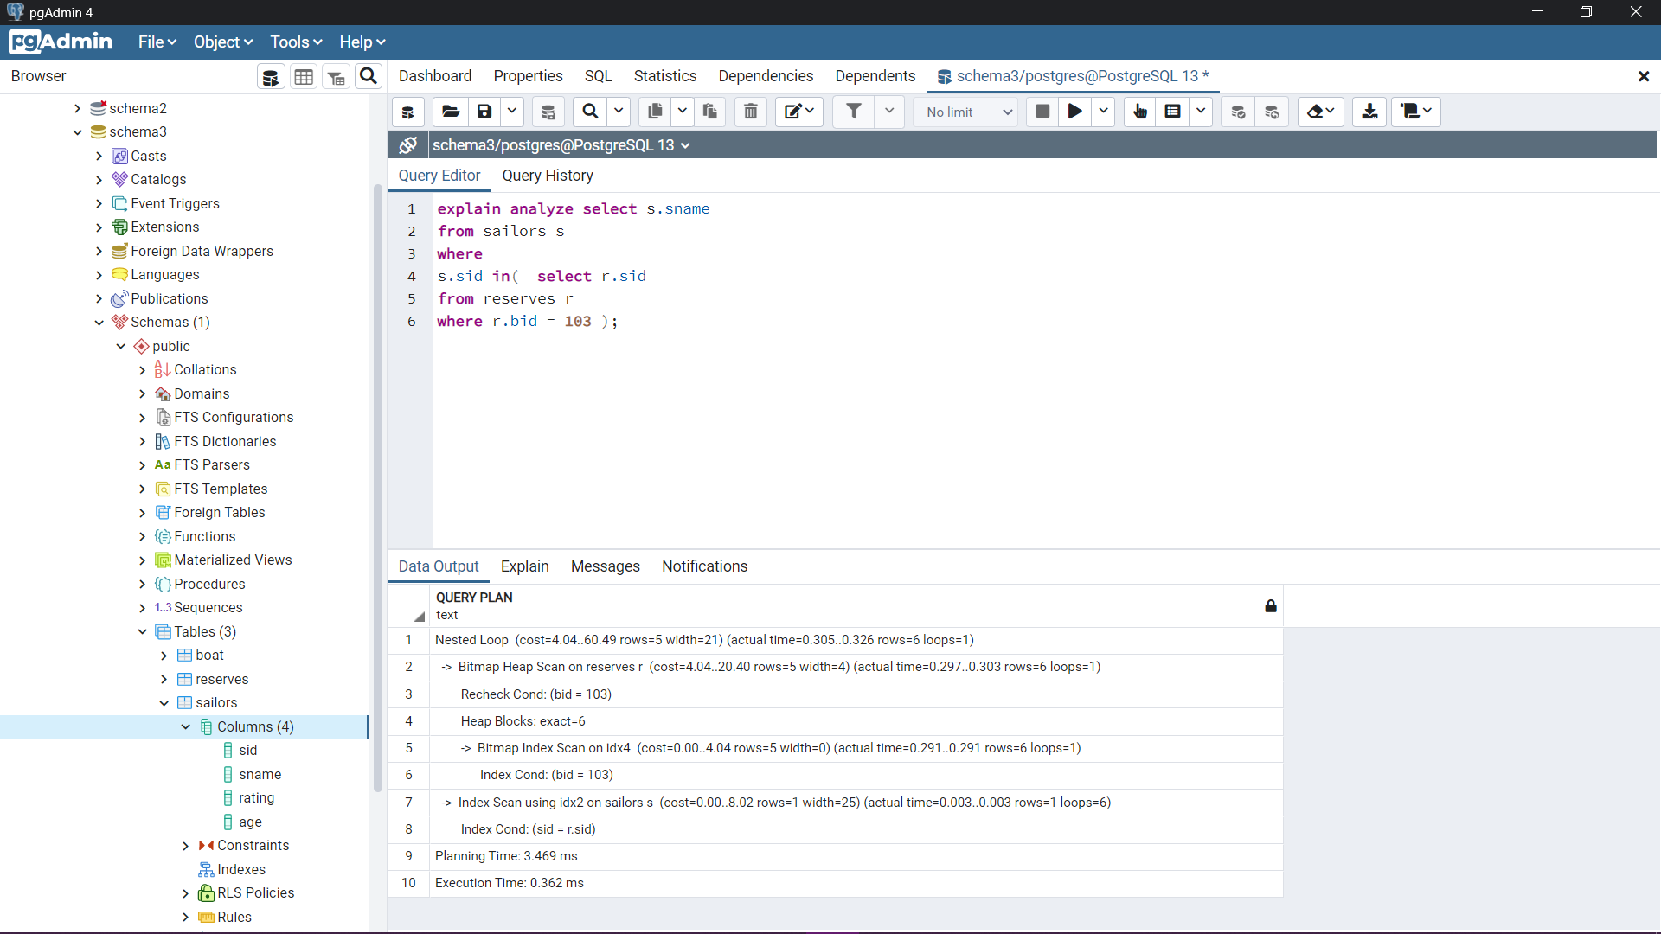

*Execution time improved drastically. As I created hash index on r.bid since hash indexes work really well with exact value queries in addition to an extra index on s.sid.*

Scenario 4 (mixed indexes):

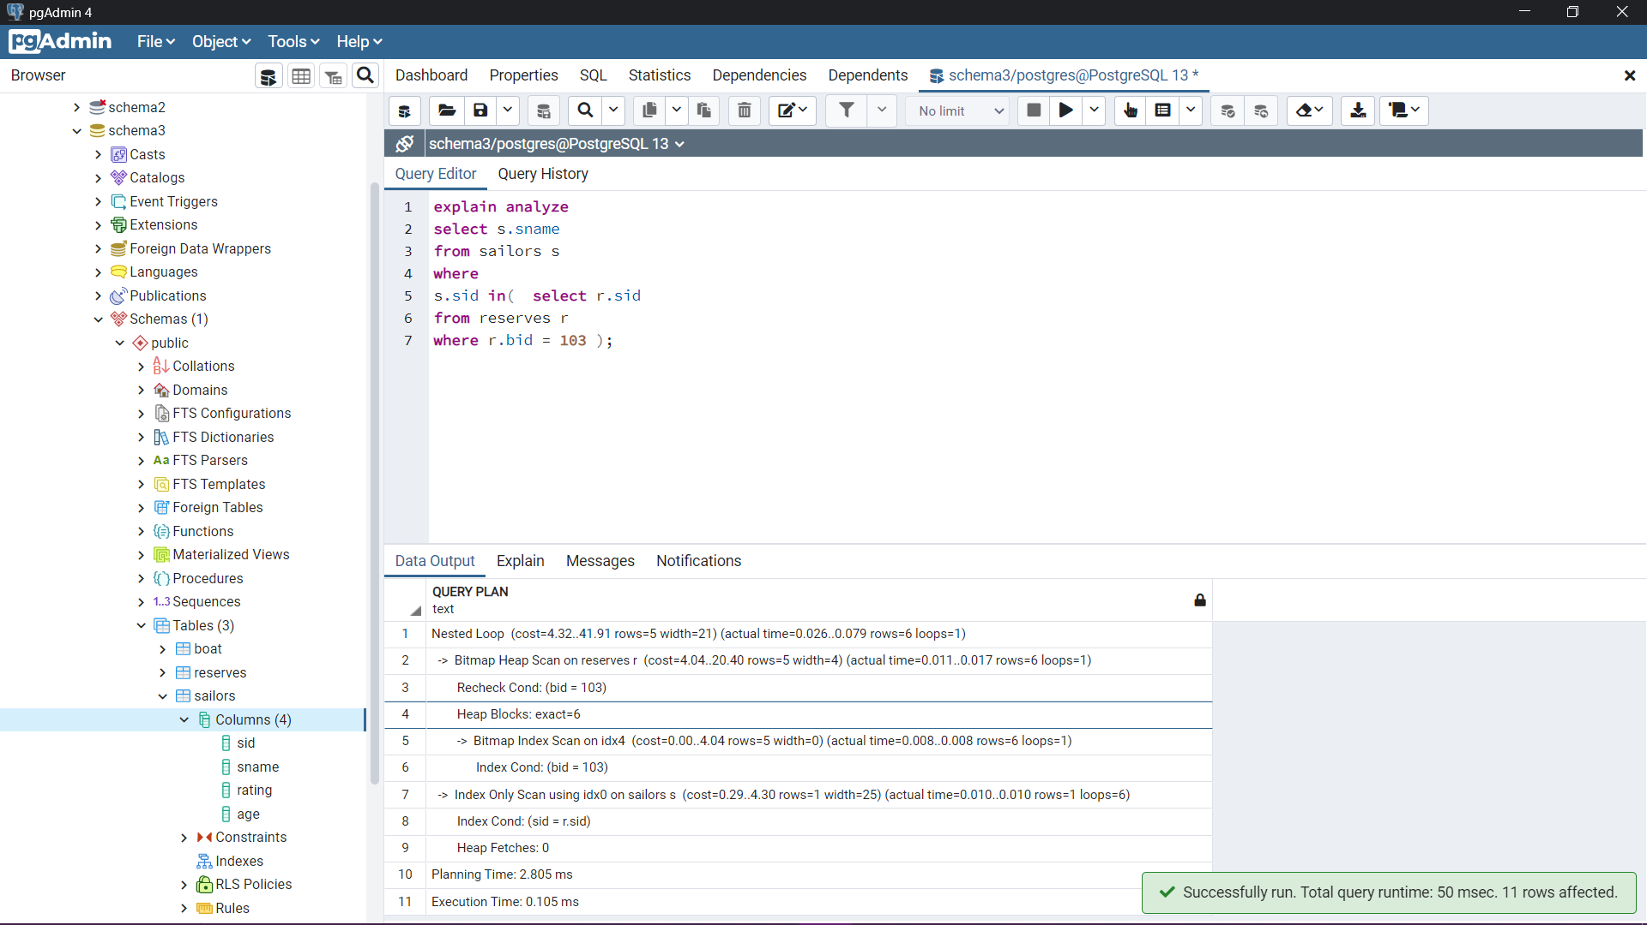

*Execution time improved drastically. As each index help in a specific way in optimizing the query.*

Query 8:

Scenario 1 (no index):

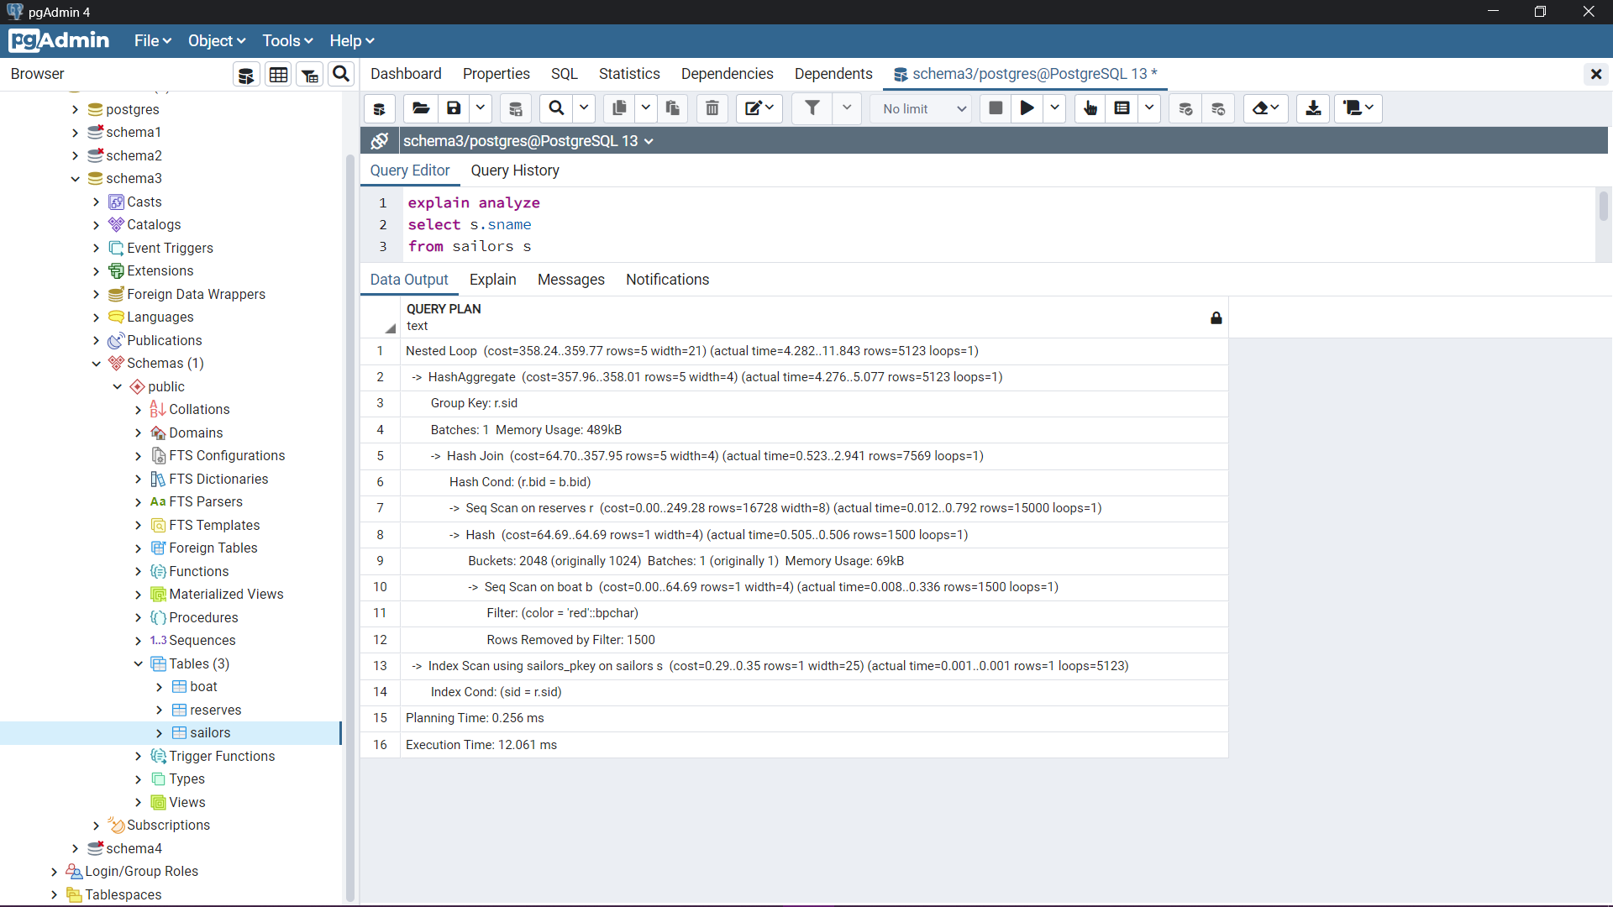

Scenario 2 (B+ tree index):

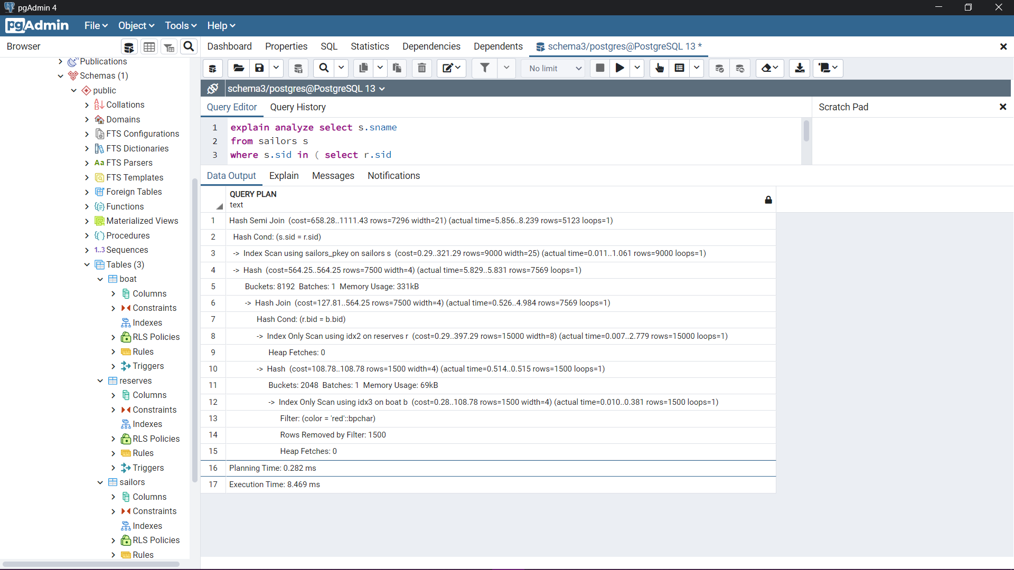

*To force Postgres to use the created indexes I used “set enable_seqscan=false”, “set enable_indexscan =true”*

Scenario 3 (Hash index):

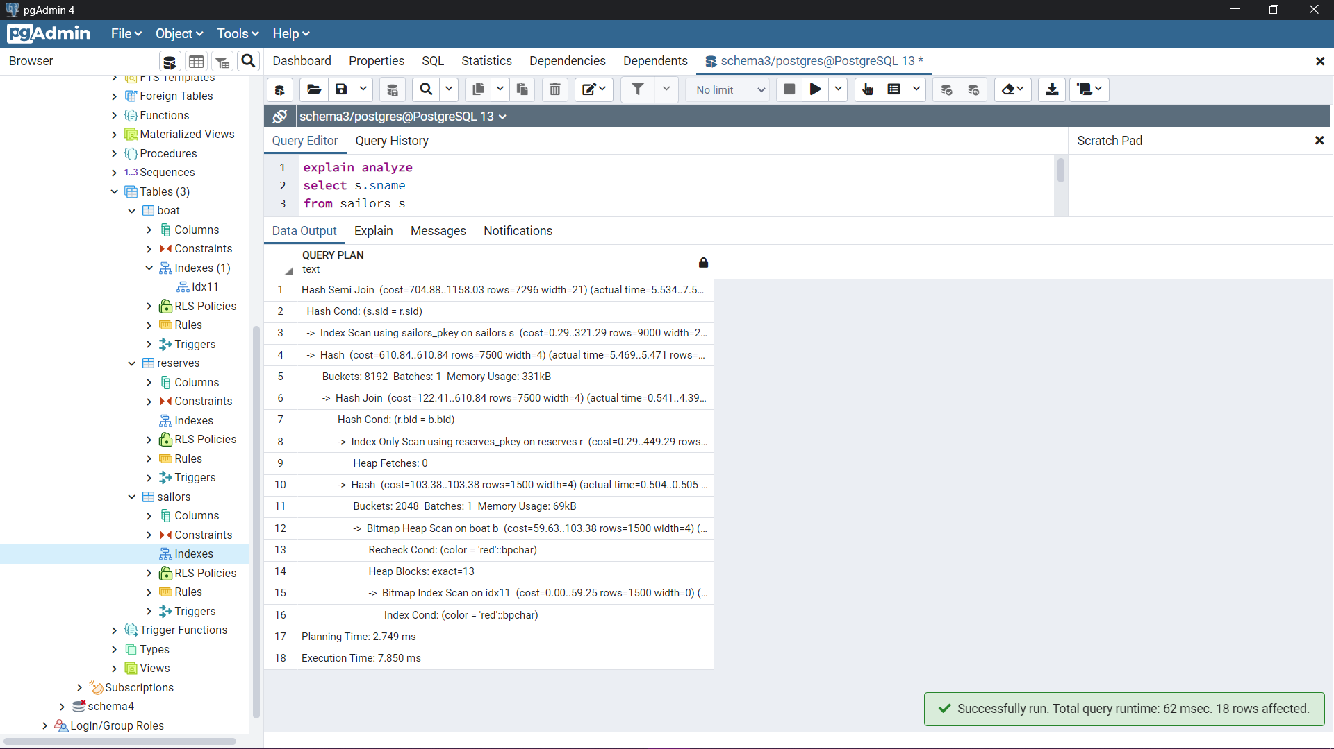

Scenario 4 (mixed indexes):

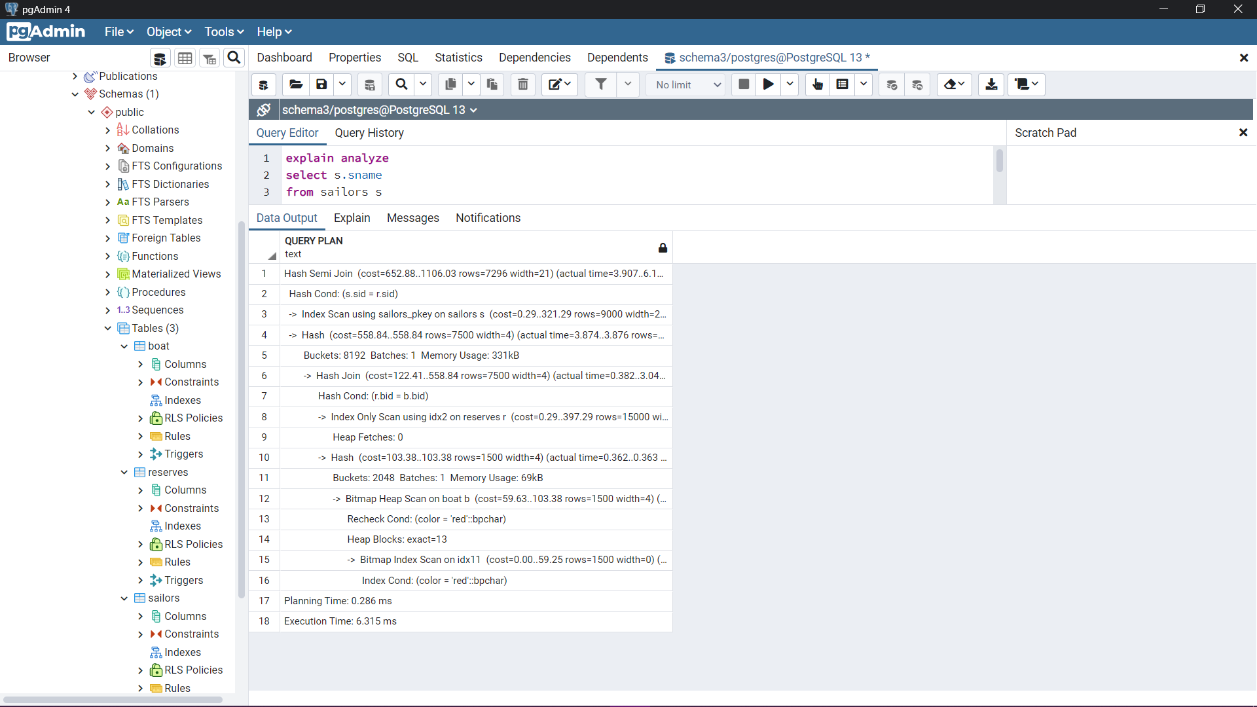

Query 9:

Scenario 1 (no index):

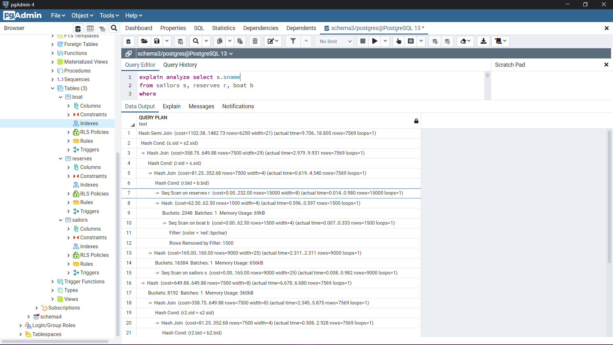

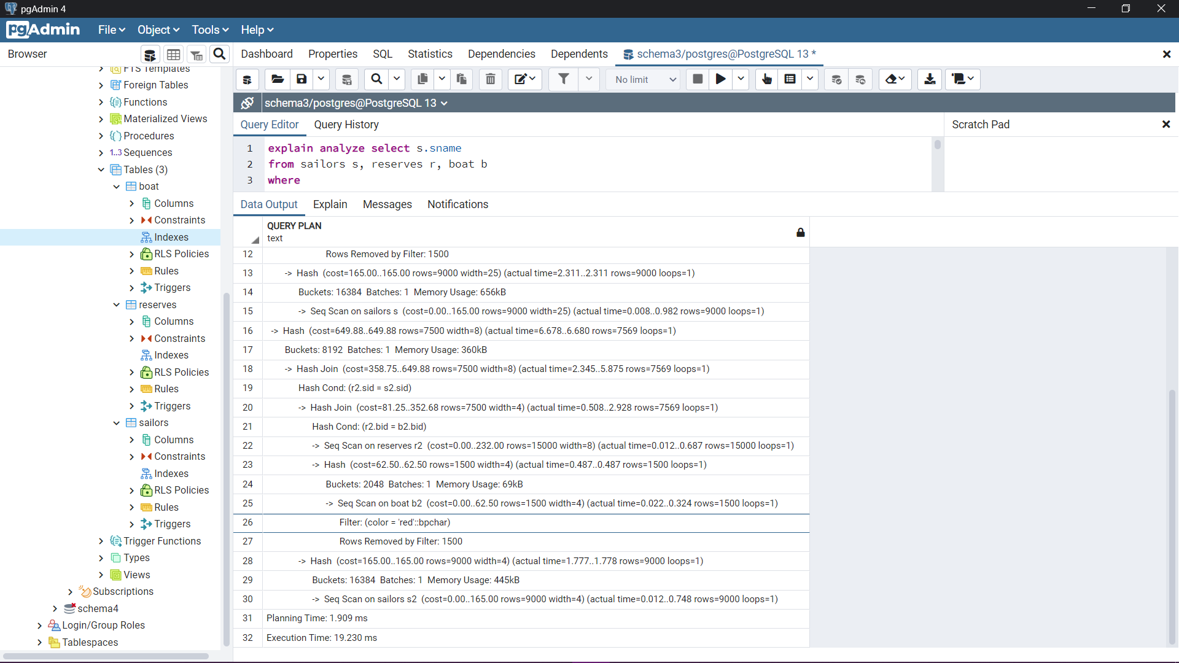

Scenario 2 (B+ tree index):

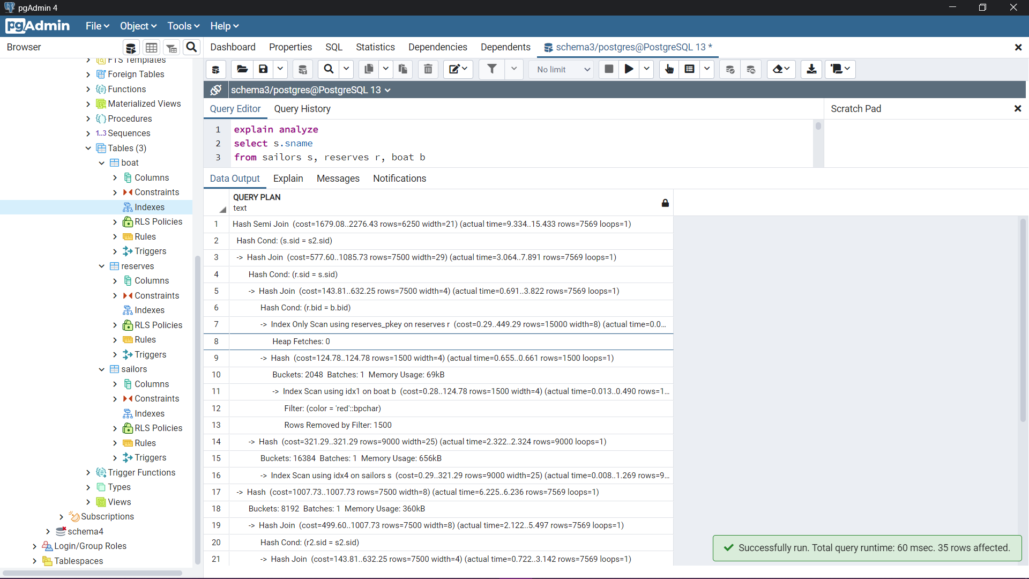

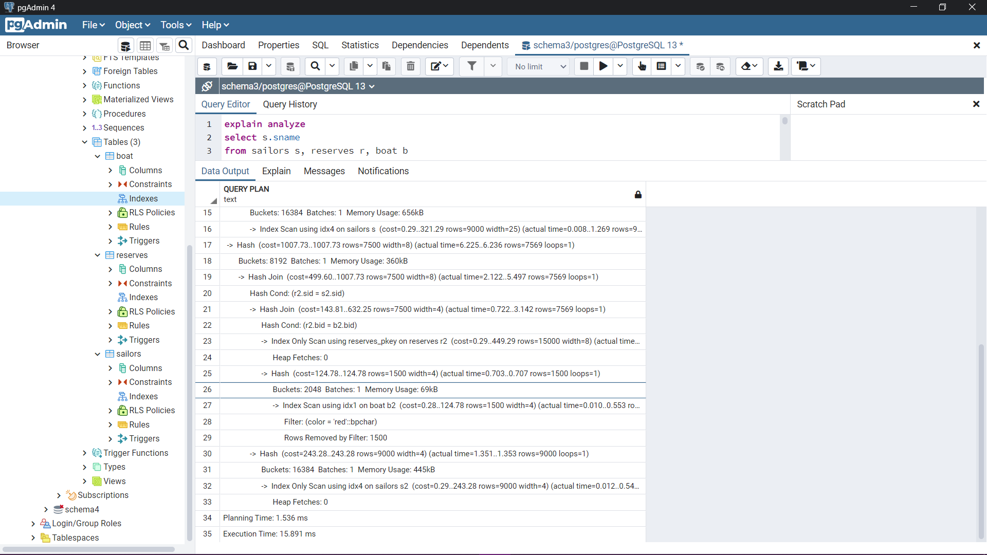

Scenario 3 (hash index):

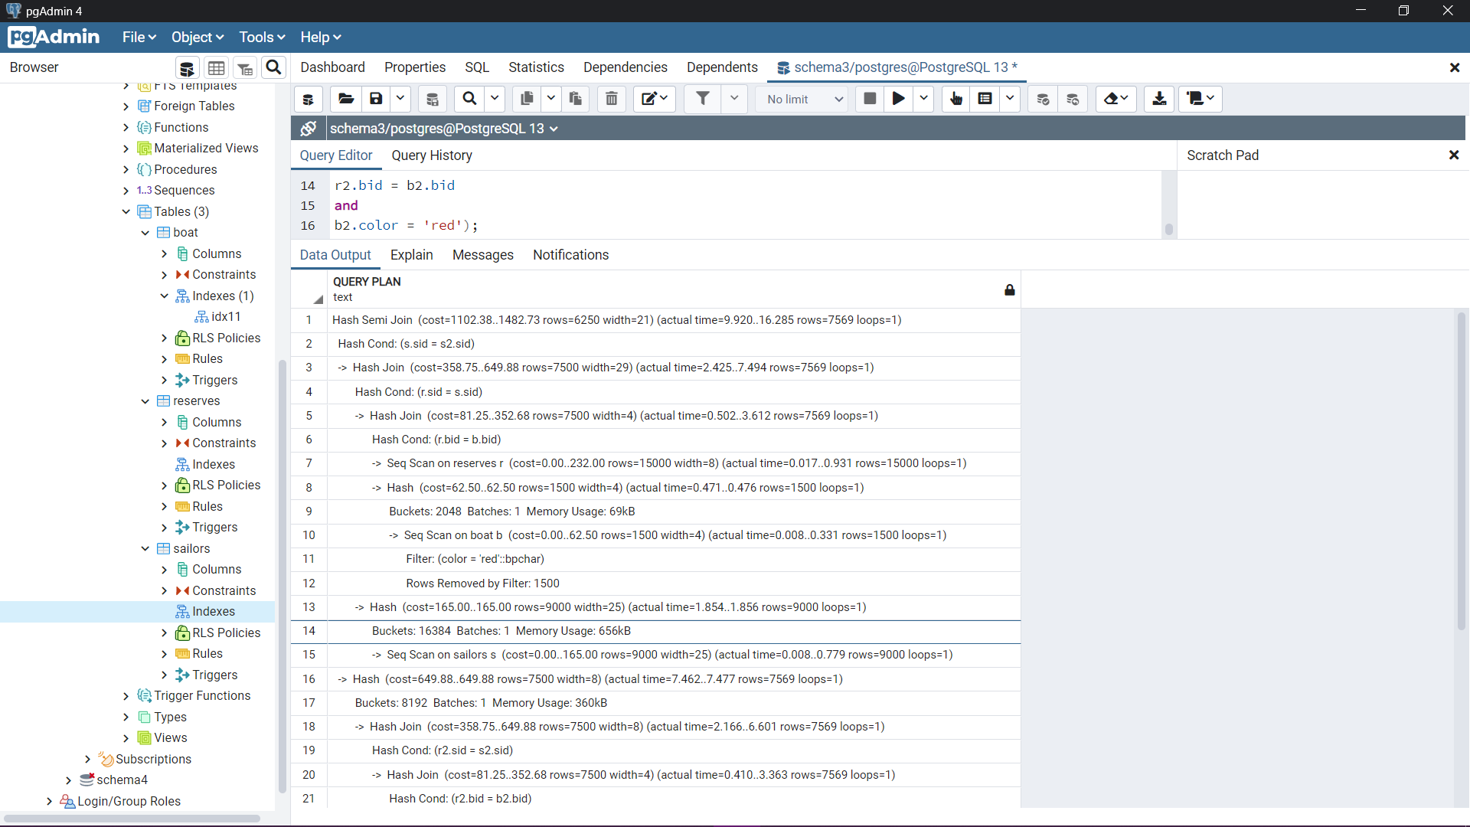

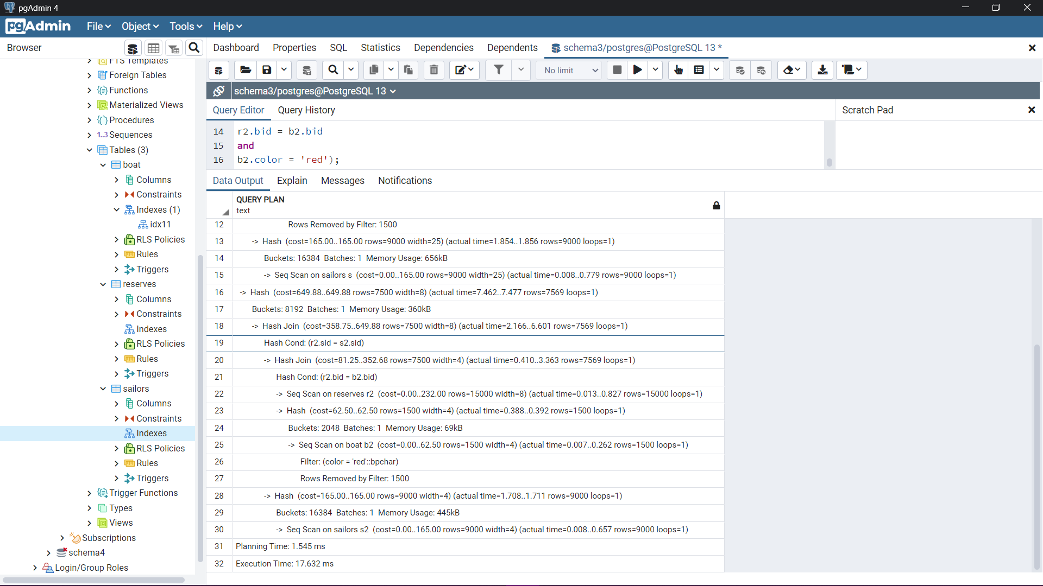

Scenario 4 (mixed indexes):

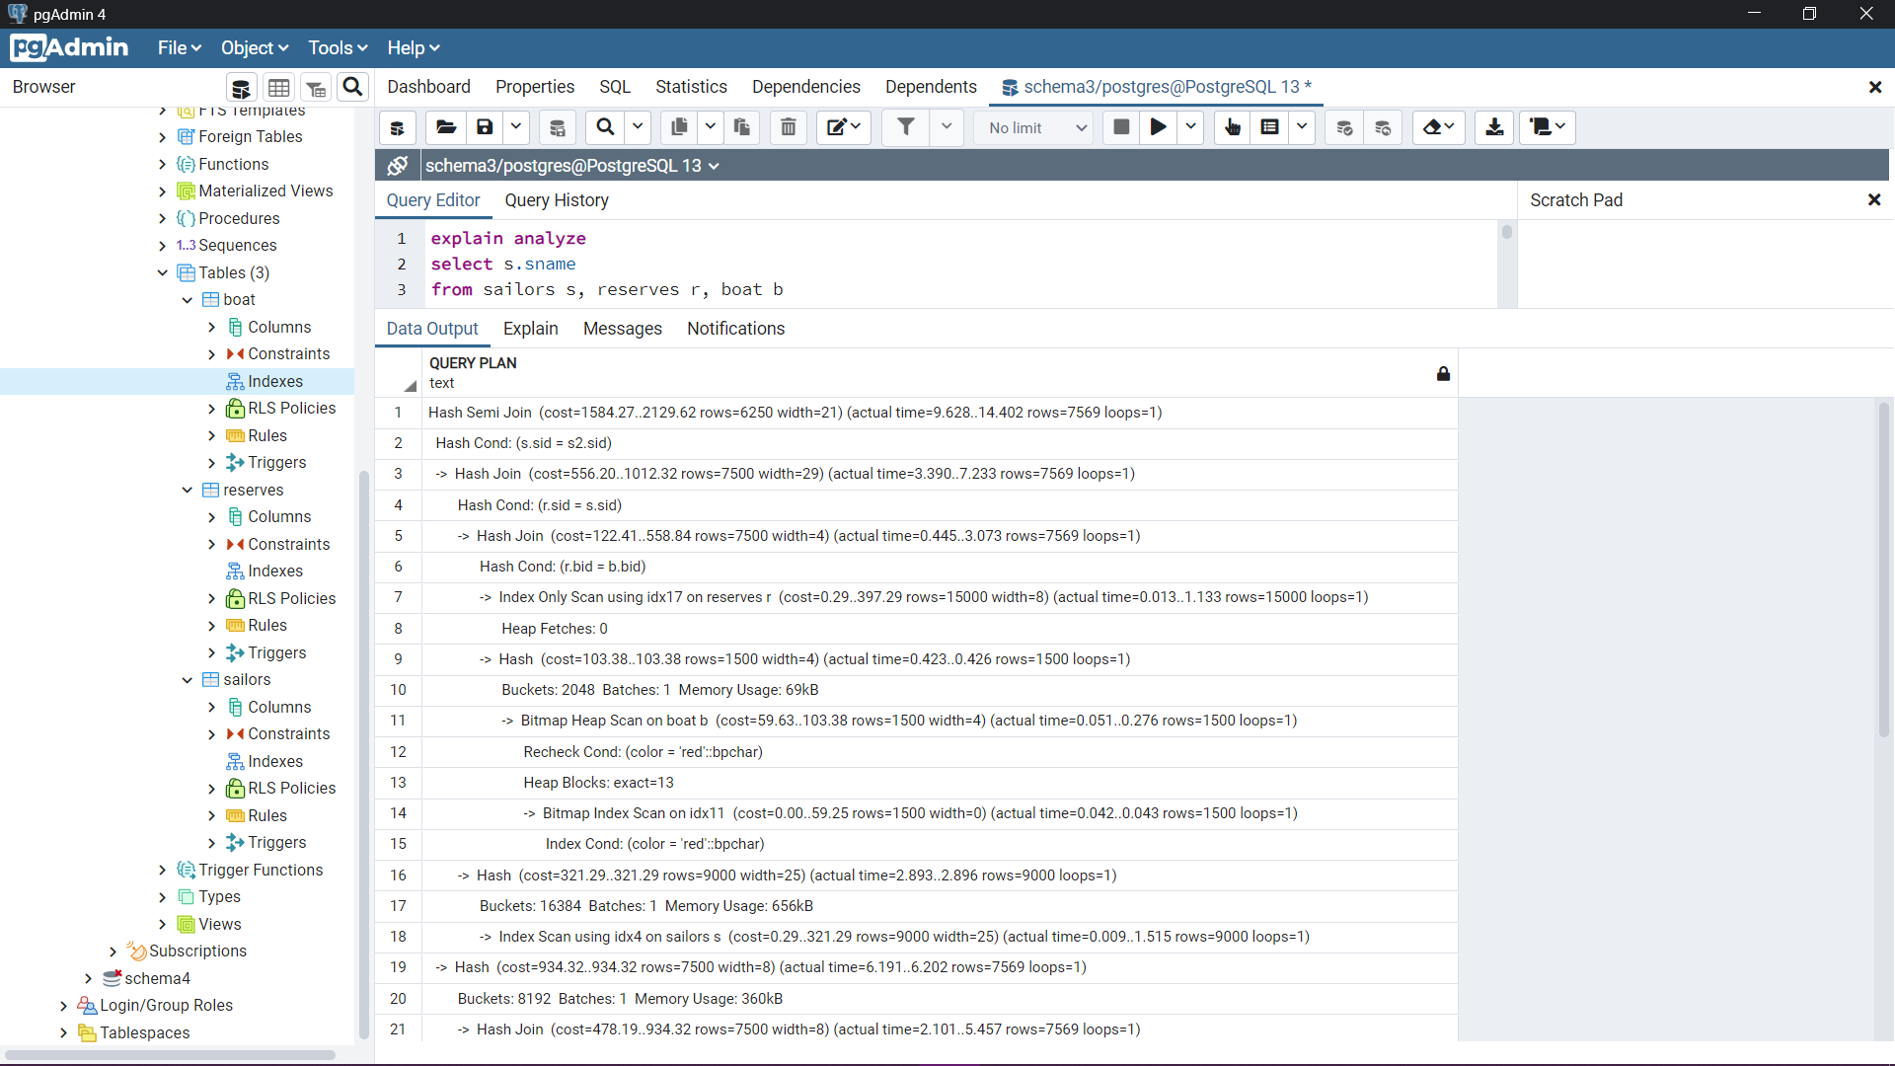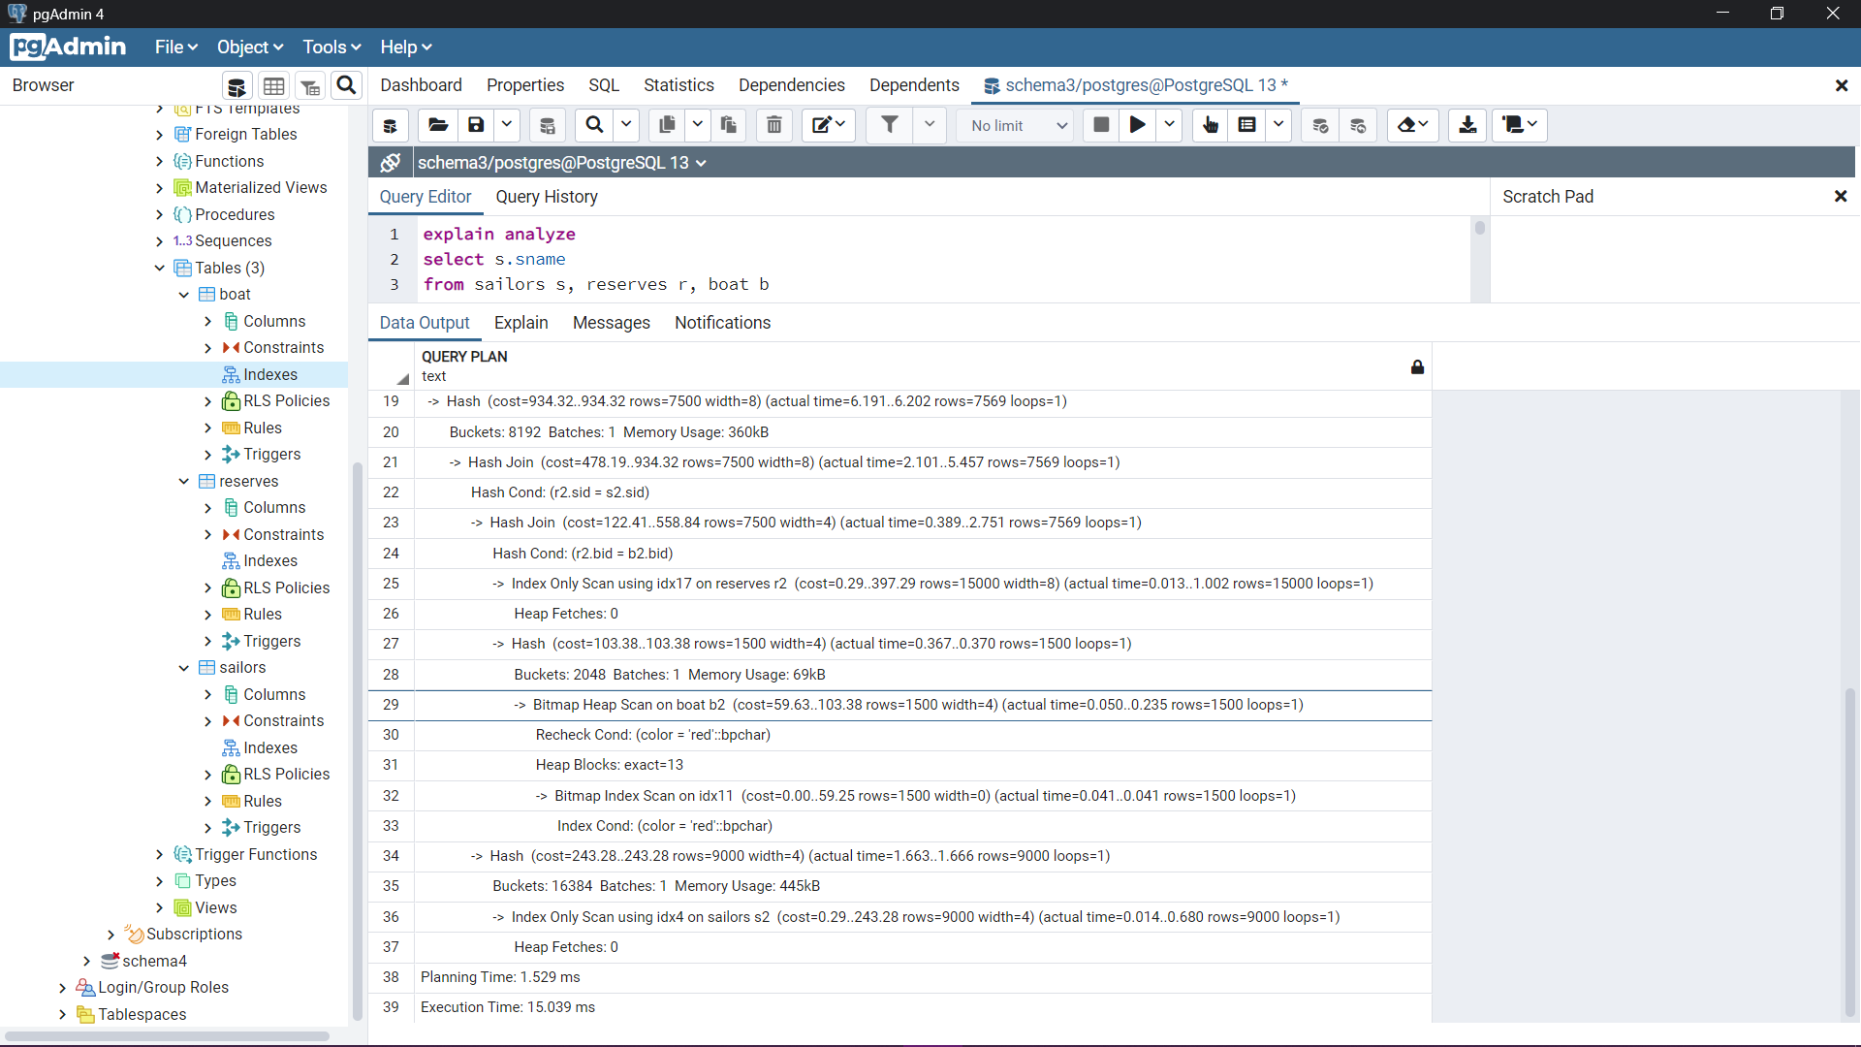

Schema 4

Query 10 without index

Query plan:

"Nested Loop (cost=228.29..231.72 rows=10 width=48) (actual time=0.162..0.163 rows=0 loops=1)"

" -> HashAggregate (cost=228.00..228.10 rows=10 width=4) (actual time=0.162..0.163 rows=0 loops=1)"

" Group Key: movie_cast.act_id"

" Batches: 1 Memory Usage: 24kB"

" -> Nested Loop (cost=0.29..227.98 rows=10 width=4) (actual time=0.162..0.162 rows=0 loops=1)"

" -> Seq Scan on movie (cost=0.00..32.50 rows=1 width=4) (actual time=0.161..0.161 rows=0 loops=1)"

" Filter: (mov_title = 'movie1'::bpchar)"

" Rows Removed by Filter: 1000"

" -> Index Only Scan using movie_cast_pkey on movie_cast (cost=0.29..195.38 rows=10 width=8) (never executed)"

" Index Cond: (mov_id = movie.mov_id)"

" Heap Fetches: 0"

" -> Index Scan using actor_pkey on actor (cost=0.29..0.36 rows=1 width=48) (never executed)"

" Index Cond: (act_id = movie_cast.act_id)"

"Planning Time: 0.322 ms"

"Execution Time: 0.202 ms"

RESULT CONCLUSION: Total time of 0.524 ms with no index.

Query 10 with B+ tree

Query plan:

"Nested Loop (cost=228.29..231.72 rows=10 width=48) (actual time=0.113..0.114 rows=0 loops=1)"

" -> HashAggregate (cost=228.00..228.10 rows=10 width=4) (actual time=0.113..0.113 rows=0 loops=1)"

" Group Key: movie_cast.act_id"

" Batches: 1 Memory Usage: 24kB"

" -> Nested Loop (cost=0.29..227.98 rows=10 width=4) (actual time=0.112..0.113 rows=0 loops=1)"

" -> Seq Scan on movie (cost=0.00..32.50 rows=1 width=4) (actual time=0.112..0.112 rows=0 loops=1)"

" Filter: (mov_title = 'movie1'::bpchar)"

" Rows Removed by Filter: 1000"

" -> Index Only Scan using movie_cast_pkey on movie_cast (cost=0.29..195.38 rows=10 width=8) (never executed)"

" Index Cond: (mov_id = movie.mov_id)"

" Heap Fetches: 0"

" -> Index Scan using in1 on actor (cost=0.29..0.36 rows=1 width=48) (never executed)"

" Index Cond: (act_id = movie_cast.act_id)"

"Planning Time: 0.313 ms"

"Execution Time: 0.134 ms"

RESULT CONCLUSION: Total time of 0.447 ms very slightly made faster when using a B+ tree index.

Query 10 with hash index

Query plan:

"Nested Loop (cost=66.48..67.47 rows=10 width=48) (actual time=0.129..0.130 rows=0 loops=1)"

" -> HashAggregate (cost=66.48..66.58 rows=10 width=4) (actual time=0.129..0.129 rows=0 loops=1)"

" Group Key: movie_cast.act_id"

" Batches: 1 Memory Usage: 24kB"

" -> Nested Loop (cost=4.08..66.45 rows=10 width=4) (actual time=0.128..0.128 rows=0 loops=1)"

" -> Seq Scan on movie (cost=0.00..32.50 rows=1 width=4) (actual time=0.127..0.127 rows=0 loops=1)"

" Filter: (mov_title = 'movie1'::bpchar)"

" Rows Removed by Filter: 1000"

" -> Bitmap Heap Scan on movie_cast (cost=4.08..33.85 rows=10 width=8) (never executed)"

" Recheck Cond: (mov_id = movie.mov_id)"

" -> Bitmap Index Scan on in2 (cost=0.00..4.08 rows=10 width=0) (never executed)"

" Index Cond: (mov_id = movie.mov_id)"

" -> Index Scan using in1 on actor (cost=0.00..0.09 rows=1 width=48) (never executed)"

" Index Cond: (act_id = movie_cast.act_id)"

"Planning Time: 0.271 ms"

"Execution Time: 0.168 ms"

RESULT CONCLUSION: Total time 0.439 ms on par with the b+ tree speed.

Query 10 with mixed index

Query plan:

"Nested Loop (cost=66.76..70.19 rows=10 width=48) (actual time=0.128..0.128 rows=0 loops=1)"

" -> HashAggregate (cost=66.48..66.58 rows=10 width=4) (actual time=0.127..0.128 rows=0 loops=1)"

" Group Key: movie_cast.act_id"

" Batches: 1 Memory Usage: 24kB"

" -> Nested Loop (cost=4.08..66.45 rows=10 width=4) (actual time=0.126..0.126 rows=0 loops=1)"

" -> Seq Scan on movie (cost=0.00..32.50 rows=1 width=4) (actual time=0.126..0.126 rows=0 loops=1)"

" Filter: (mov_title = 'movie1'::bpchar)"

" Rows Removed by Filter: 1000"

" -> Bitmap Heap Scan on movie_cast (cost=4.08..33.85 rows=10 width=8) (never executed)"

" Recheck Cond: (mov_id = movie.mov_id)"

" -> Bitmap Index Scan on in2 (cost=0.00..4.08 rows=10 width=0) (never executed)"

" Index Cond: (mov_id = movie.mov_id)"

" -> Index Scan using in1 on actor (cost=0.29..0.36 rows=1 width=48) (never executed)"

" Index Cond: (act_id = movie_cast.act_id)"

"Planning Time: 0.266 ms"

"Execution Time: 0.158 ms"

RESULT CONCLUSION: Total time of 0.424 ms giving the best result set by mixing both hash based and b+ index for this query.

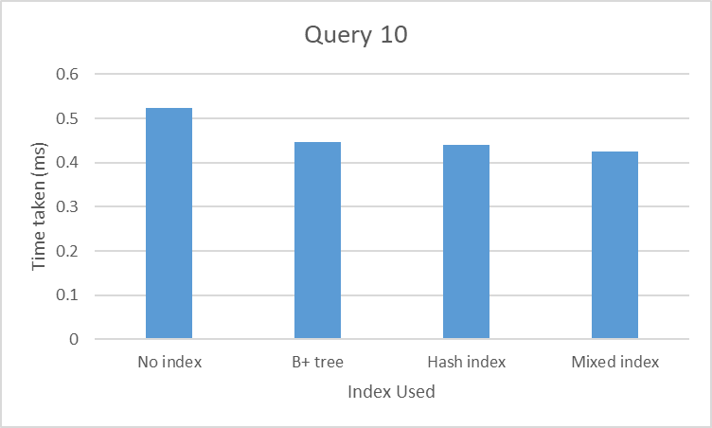

Query 11 without index

Query plan:

"Nested Loop (cost=626.34..661.64 rows=100 width=42) (actual time=0.151..0.153 rows=0 loops=1)"

" -> HashAggregate (cost=626.06..627.06 rows=100 width=4) (actual time=0.151..0.152 rows=0 loops=1)"

" Group Key: movie_direction.dir_id"

" Batches: 1 Memory Usage: 24kB"

" -> Hash Semi Join (cost=453.46..625.81 rows=100 width=4) (actual time=0.150..0.151 rows=0 loops=1)"

" Hash Cond: (movie_direction.mov_id = movie_cast.mov_id)"

" -> Seq Scan on movie_direction (cost=0.00..144.99 rows=9999 width=8) (actual time=0.010..0.010 rows=1 loops=1)"

" -> Hash (cost=453.33..453.33 rows=10 width=4) (actual time=0.138..0.139 rows=0 loops=1)"

" Buckets: 1024 Batches: 1 Memory Usage: 8kB"

" -> Hash Semi Join (cost=242.99..453.33 rows=10 width=4) (actual time=0.137..0.138 rows=0 loops=1)"

" Hash Cond: (movie_cast.role = movie_cast_1.role)"

" -> Seq Scan on movie_cast (cost=0.00..183.99 rows=9999 width=35) (actual time=0.005..0.006 rows=1 loops=1)"

" -> Hash (cost=242.86..242.86 rows=10 width=31) (actual time=0.130..0.131 rows=0 loops=1)"

" Buckets: 1024 Batches: 1 Memory Usage: 8kB"

" -> Hash Join (cost=32.51..242.86 rows=10 width=31) (actual time=0.130..0.131 rows=0 loops=1)"

" Hash Cond: (movie_cast_1.mov_id = movie.mov_id)"

" -> Seq Scan on movie_cast movie_cast_1 (cost=0.00..183.99 rows=9999 width=35) (actual time=0.005..0.005 rows=1 loops=1)"

" -> Hash (cost=32.50..32.50 rows=1 width=4) (actual time=0.125..0.125 rows=0 loops=1)"

" Buckets: 1024 Batches: 1 Memory Usage: 8kB"

" -> Seq Scan on movie (cost=0.00..32.50 rows=1 width=4) (actual time=0.124..0.124 rows=0 loops=1)"

" Filter: (mov_title = 'movie"

"2'::bpchar)"

" Rows Removed by Filter: 1000"

" -> Index Scan using director_pkey on director (cost=0.28..0.35 rows=1 width=46) (never executed)"

" Index Cond: (dir_id = movie_direction.dir_id)"

"Planning Time: 0.387 ms"

"Execution Time: 0.181 ms"

RESULT CONCLUSION: Total time 0.568 ms without an index.

Query 11 with B+ tree

Query plan:

"Nested Loop (cost=450.21..485.52 rows=100 width=42) (actual time=0.129..0.131 rows=0 loops=1)"

" -> HashAggregate (cost=449.94..450.94 rows=100 width=4) (actual time=0.129..0.130 rows=0 loops=1)"

" Group Key: movie_direction.dir_id"

" Batches: 1 Memory Usage: 24kB"

" -> Hash Semi Join (cost=277.34..449.69 rows=100 width=4) (actual time=0.128..0.129 rows=0 loops=1)"

" Hash Cond: (movie_direction.mov_id = movie_cast.mov_id)"

" -> Seq Scan on movie_direction (cost=0.00..144.99 rows=9999 width=8) (actual time=0.007..0.008 rows=1 loops=1)"

" -> Hash (cost=277.21..277.21 rows=10 width=4) (actual time=0.119..0.119 rows=0 loops=1)"

" Buckets: 1024 Batches: 1 Memory Usage: 8kB"

" -> Hash Semi Join (cost=66.86..277.21 rows=10 width=4) (actual time=0.118..0.119 rows=0 loops=1)"

" Hash Cond: (movie_cast.role = movie_cast_1.role)"

" -> Seq Scan on movie_cast (cost=0.00..183.99 rows=9999 width=35) (actual time=0.005..0.005 rows=1 loops=1)"

" -> Hash (cost=66.74..66.74 rows=10 width=31) (actual time=0.112..0.112 rows=0 loops=1)"

" Buckets: 1024 Batches: 1 Memory Usage: 8kB"

" -> Nested Loop (cost=4.36..66.74 rows=10 width=31) (actual time=0.111..0.112 rows=0 loops=1)"

" -> Seq Scan on movie (cost=0.00..32.50 rows=1 width=4) (actual time=0.111..0.111 rows=0 loops=1)"

" Filter: (mov_title = 'movie"

"2'::bpchar)"

" Rows Removed by Filter: 1000"

" -> Bitmap Heap Scan on movie_cast movie_cast_1 (cost=4.36..34.14 rows=10 width=35) (never executed)"

" Recheck Cond: (mov_id = movie.mov_id)"

" -> Bitmap Index Scan on in3 (cost=0.00..4.36 rows=10 width=0) (never executed)"

" Index Cond: (mov_id = movie.mov_id)"

" -> Index Scan using in1 on director (cost=0.28..0.35 rows=1 width=46) (never executed)"

" Index Cond: (dir_id = movie_direction.dir_id)"

"Planning Time: 0.445 ms"

"Execution Time: 0.168 ms"

RESULT CONCLUSION: total time of 0.613 ms which is a significant increase from using no index.

Query 11 with hash index

Query plan:

"Nested Loop (cost=449.65..457.86 rows=100 width=42) (actual time=0.174..0.176 rows=0 loops=1)"

" -> HashAggregate (cost=449.65..450.65 rows=100 width=4) (actual time=0.174..0.175 rows=0 loops=1)"

" Group Key: movie_direction.dir_id"

" Batches: 1 Memory Usage: 24kB"

" -> Hash Semi Join (cost=277.05..449.40 rows=100 width=4) (actual time=0.172..0.174 rows=0 loops=1)"

" Hash Cond: (movie_direction.mov_id = movie_cast.mov_id)"

" -> Seq Scan on movie_direction (cost=0.00..144.99 rows=9999 width=8) (actual time=0.007..0.007 rows=1 loops=1)"

" -> Hash (cost=276.93..276.93 rows=10 width=4) (actual time=0.163..0.164 rows=0 loops=1)"

" Buckets: 1024 Batches: 1 Memory Usage: 8kB"

" -> Hash Semi Join (cost=66.58..276.93 rows=10 width=4) (actual time=0.163..0.164 rows=0 loops=1)"

" Hash Cond: (movie_cast.role = movie_cast_1.role)"

" -> Seq Scan on movie_cast (cost=0.00..183.99 rows=9999 width=35) (actual time=0.005..0.005 rows=1 loops=1)"

" -> Hash (cost=66.45..66.45 rows=10 width=31) (actual time=0.157..0.157 rows=0 loops=1)"

" Buckets: 1024 Batches: 1 Memory Usage: 8kB"

" -> Nested Loop (cost=4.08..66.45 rows=10 width=31) (actual time=0.156..0.157 rows=0 loops=1)"

" -> Seq Scan on movie (cost=0.00..32.50 rows=1 width=4) (actual time=0.156..0.156 rows=0 loops=1)"

" Filter: (mov_title = 'movie"

"2'::bpchar)"

" Rows Removed by Filter: 1000"

" -> Bitmap Heap Scan on movie_cast movie_cast_1 (cost=4.08..33.85 rows=10 width=35) (never executed)"

" Recheck Cond: (mov_id = movie.mov_id)"

" -> Bitmap Index Scan on in3 (cost=0.00..4.08 rows=10 width=0) (never executed)"

" Index Cond: (mov_id = movie.mov_id)"

" -> Index Scan using in1 on director (cost=0.00..0.08 rows=1 width=46) (never executed)"

" Index Cond: (dir_id = movie_direction.dir_id)"

"Planning Time: 0.476 ms"

"Execution Time: 0.209 ms"

RESULT CONCLUSION: Total time of 0.685 ms an even greater decrease in performance from using b+ index.

Query 11 with mixed index

Query plan:

"Nested Loop (cost=449.93..485.23 rows=100 width=42) (actual time=0.270..0.273 rows=0 loops=1)"

" -> HashAggregate (cost=449.65..450.65 rows=100 width=4) (actual time=0.269..0.272 rows=0 loops=1)"

" Group Key: movie_direction.dir_id"

" Batches: 1 Memory Usage: 24kB"

" -> Hash Semi Join (cost=277.05..449.40 rows=100 width=4) (actual time=0.267..0.270 rows=0 loops=1)"

" Hash Cond: (movie_direction.mov_id = movie_cast.mov_id)"

" -> Seq Scan on movie_direction (cost=0.00..144.99 rows=9999 width=8) (actual time=0.012..0.012 rows=1 loops=1)"

" -> Hash (cost=276.93..276.93 rows=10 width=4) (actual time=0.251..0.254 rows=0 loops=1)"

" Buckets: 1024 Batches: 1 Memory Usage: 8kB"

" -> Hash Semi Join (cost=66.58..276.93 rows=10 width=4) (actual time=0.251..0.253 rows=0 loops=1)"

" Hash Cond: (movie_cast.role = movie_cast_1.role)"

" -> Seq Scan on movie_cast (cost=0.00..183.99 rows=9999 width=35) (actual time=0.008..0.008 rows=1 loops=1)"

" -> Hash (cost=66.45..66.45 rows=10 width=31) (actual time=0.241..0.242 rows=0 loops=1)"

" Buckets: 1024 Batches: 1 Memory Usage: 8kB"

" -> Nested Loop (cost=4.08..66.45 rows=10 width=31) (actual time=0.240..0.241 rows=0 loops=1)"

" -> Seq Scan on movie (cost=0.00..32.50 rows=1 width=4) (actual time=0.240..0.240 rows=0 loops=1)"

" Filter: (mov_title = 'movie"

"2'::bpchar)"

" Rows Removed by Filter: 1000"

" -> Bitmap Heap Scan on movie_cast movie_cast_1 (cost=4.08..33.85 rows=10 width=35) (never executed)"

" Recheck Cond: (mov_id = movie.mov_id)"

" -> Bitmap Index Scan on in3 (cost=0.00..4.08 rows=10 width=0) (never executed)"

" Index Cond: (mov_id = movie.mov_id)"

" -> Index Scan using in1 on director (cost=0.28..0.35 rows=1 width=46) (never executed)"

" Index Cond: (dir_id = movie_direction.dir_id)"

"Planning Time: 0.446 ms"

"Execution Time: 0.323 ms"

RESULT CONCLUSION: Total time 0.769 ms which shows that using mixed index provides a significant decrease in performance on this partical query.

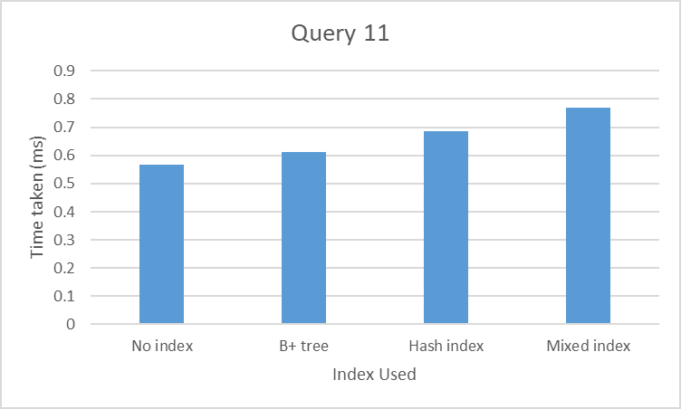

Query 12 without index

Query plan :

"Index Scan using movie_pkey on movie (cost=53.65..61.67 rows=1 width=51) (actual time=0.182..0.183 rows=0 loops=1)"

" Index Cond: (mov_id = $1)"

" InitPlan 2 (returns $1)"

" -> Index Only Scan using movie_direction_pkey on movie_direction (cost=49.28..53.37 rows=5 width=4) (actual time=0.180..0.180 rows=0 loops=1)"

" Index Cond: (dir_id = $0)"

" Heap Fetches: 0"

" InitPlan 1 (returns $0)"

" -> Seq Scan on director (cost=0.00..49.00 rows=1 width=4) (actual time=0.177..0.177 rows=0 loops=1)"

" Filter: ((dir_fname = 'actor1'::bpchar) AND (dir_lname = 'actor1'::bpchar))"

" Rows Removed by Filter: 2000"

"Planning Time: 0.110 ms"

"Execution Time: 0.200 ms"

RESULT CONCLUSION: Total time of 0.310 ms without an index.

Query 12 with b+ tree

Query plan :

"Index Scan using in1 on movie (cost=53.65..61.67 rows=1 width=51) (actual time=0.185..0.186 rows=0 loops=1)"

" Index Cond: (mov_id = $1)"

" InitPlan 2 (returns $1)"

" -> Index Only Scan using movie_direction_pkey on movie_direction (cost=49.28..53.37 rows=5 width=4) (actual time=0.183..0.184 rows=0 loops=1)"

" Index Cond: (dir_id = $0)"

" Heap Fetches: 0"

" InitPlan 1 (returns $0)"

" -> Seq Scan on director (cost=0.00..49.00 rows=1 width=4) (actual time=0.180..0.180 rows=0 loops=1)"

" Filter: ((dir_fname = 'actor1'::bpchar) AND (dir_lname = 'actor1'::bpchar))"

" Rows Removed by Filter: 2000"

"Planning Time: 0.125 ms"

"Execution Time: 0.203 ms"

RESULT CONCLUSION: Total time of 0.328 ms not a significant change from using no index.

Query 12 with hash index

Query plan :

"Index Scan using in1 on movie (cost=53.37..61.39 rows=1 width=51) (actual time=0.220..0.221 rows=0 loops=1)"

" Index Cond: (mov_id = $1)"

" InitPlan 2 (returns $1)"

" -> Index Only Scan using movie_direction_pkey on movie_direction (cost=49.28..53.37 rows=5 width=4) (actual time=0.218..0.219 rows=0 loops=1)"

" Index Cond: (dir_id = $0)"

" Heap Fetches: 0"

" InitPlan 1 (returns $0)"

" -> Seq Scan on director (cost=0.00..49.00 rows=1 width=4) (actual time=0.199..0.199 rows=0 loops=1)"

" Filter: ((dir_fname = 'actor1'::bpchar) AND (dir_lname = 'actor1'::bpchar))"

" Rows Removed by Filter: 2000"

"Planning Time: 0.143 ms"

"Execution Time: 0.259 ms"

RESULT CONCLUSION: Total time of 0.402 ms a significant performance decrease using a hash index.

Query 12 with mixed index

Query plan :

"Index Scan using in1 on movie (cost=53.37..61.39 rows=1 width=51) (actual time=0.243..0.244 rows=0 loops=1)"

" Index Cond: (mov_id = $1)"

" InitPlan 2 (returns $1)"

" -> Index Only Scan using movie_direction_pkey on movie_direction (cost=49.28..53.37 rows=5 width=4) (actual time=0.241..0.241 rows=0 loops=1)"

" Index Cond: (dir_id = $0)"

" Heap Fetches: 0"

" InitPlan 1 (returns $0)"

" -> Seq Scan on director (cost=0.00..49.00 rows=1 width=4) (actual time=0.236..0.236 rows=0 loops=1)"

" Filter: ((dir_fname = 'actor1'::bpchar) AND (dir_lname = 'actor1'::bpchar))"

" Rows Removed by Filter: 2000"

"Planning Time: 0.116 ms"

"Execution Time: 0.283 ms"

RESULT CONCLUSION: Total time 0.399 ms using mixed index gave similar results to using a hash index both being lower performance wise from no index or

b+ tree index.

